

LAB MANUAL

SUBMITTED TO
Mr. Arham
SUBMITTED BY
Amna Shahzad
COURSE CODE
DS-303
REGISTRATION NO
2023-BS-AI-027

Bachelor of Science in Artificial Intelligence
DEPARTMENT OF COMPUTER SCIENCE

Table of Contents
LAB 01 3
LAB 02 15
LAB 03 20
LAB 04 23
LAB 05 27
LAB 06 29
LAB 07 33
LAB 08 37
LAB 09 45
LAB 10 53
LAB 11 60
LAB 13 79
LAB 14 87
LAB 15 93

LAB 01
INTRODUCTION TO DATA MINING
OBJECTIVE:
- Understand the concept and applications of Data Mining
- Use Google Colab as a development environment
- Identify different types of datasets used in Data Mining
REQUIRED SOFTWARE / TOOLS
- Web Browser
- Google Account
- Google Colab
- Python (pre-installed in Colab)
Introduction to Data Mining
Data Mining is the process of discovering useful patterns, trends, and knowledge from large datasets using statistical, machine learning, and computational techniques.
Applications of Data Mining:
- Market basket analysis
- Fraud detection
- Healthcare diagnosis
- Social media analysis
- Recommendation systems
Software Introduction – Google Colab
What is Google Colab?
Google Colaboratory (Colab) is a free cloud-based platform that allows users to write and execute Python code using a browser.
Features
- No installation required
- Free access to GPU/TPU
- Easy sharing and collaboration
- Pre-installed libraries (NumPy, Pandas, Matplotlib, etc.)
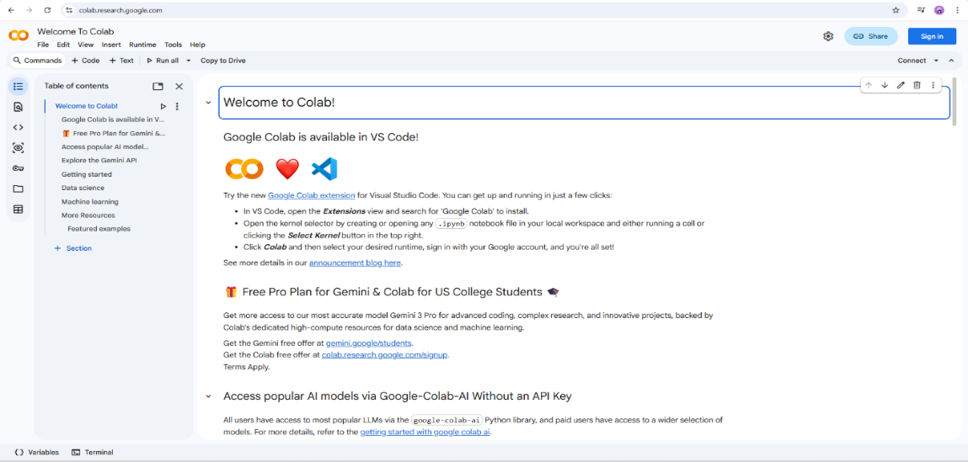
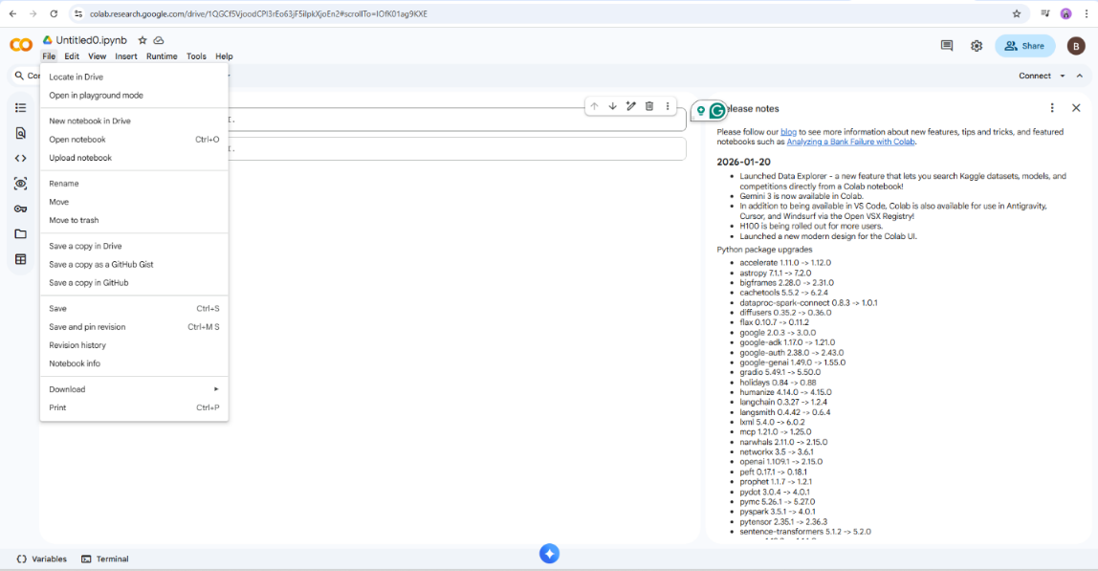
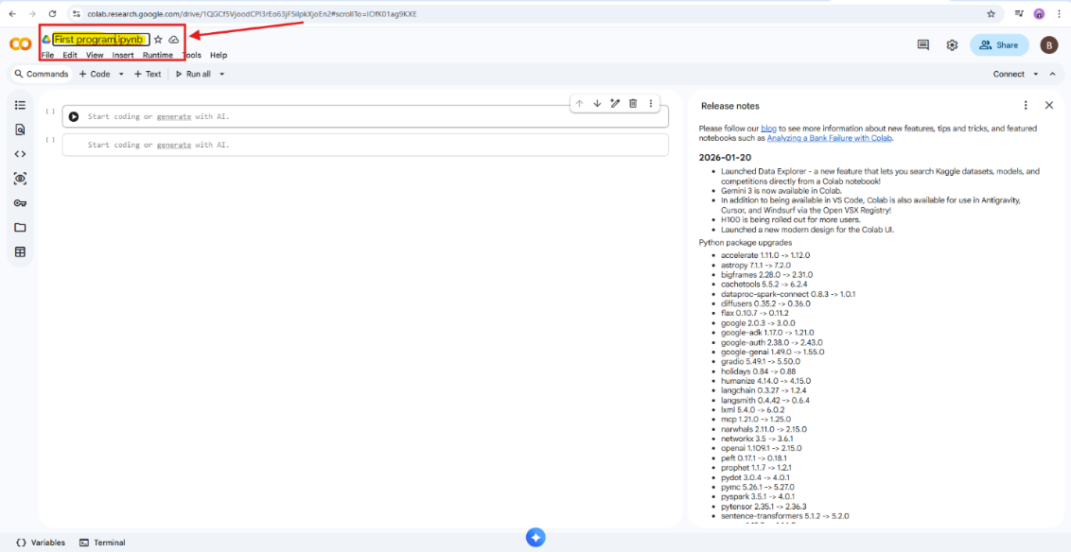
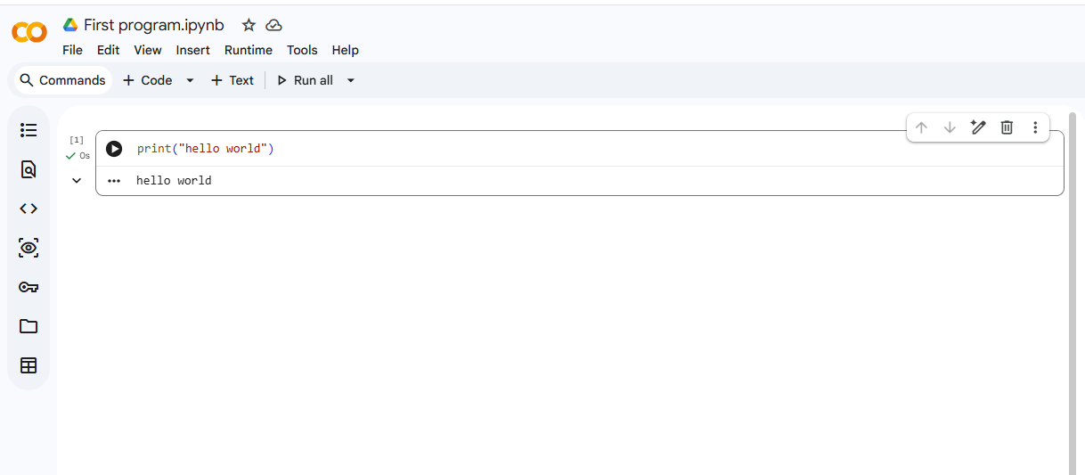
Overview of datasets
What is a Dataset in Data Mining?
A dataset is a structured collection of data used to discover patterns, relationships, or knowledge through data mining techniques.
In labs, datasets are usually stored as tables (rows = records, columns = attributes).
Common Types of Datasets
Structured Datasets
Data is organized in rows and columns.
Examples:
- Student performance data
- Sales transactions
- Bank customer records
Formats: CSV, Excel, SQL tables
Used for: Classification, clustering, regression
Transactional Datasets
Each record represents a transaction with a set of items.
Example:
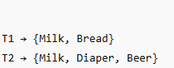
Used for:
- Association rule mining
- Market basket analysis
(Algorithms: Apriori, FP-Growth)
Time-Series Datasets
Data collected over time at regular intervals.
Examples:
- Stock prices
- Temperature readings
- Website traffic per day
Used for:
- Trend analysis
- Forecasting
- Sequential pattern mining
Spatial or Geographical Datasets
Data related to location or space.
Examples:
- GPS coordinates
- Maps
- Satellite images
Used for:
- Spatial clustering
- Location-based analysis
Text Datasets
Data in textual form.
Examples:
- Emails
- Reviews
- Tweets
Used for:
- Text mining
- Sentiment analysis
- Topic modeling
Web and Log Datasets
Data generated from web activity.
Examples:
- Clickstream data
- Server logs
- User browsing history
Used for:
- Web usage mining
- Recommendation systems
Attributes in a Dataset
1 Numerical Attributes
- Integer or real values
- Example: Age, Salary
2 Categorical Attributes
- Distinct categories
- Example: Gender, Department
3 Binary Attributes
- Two possible values
- Example: Yes/No, 0/1
How to download the dataset
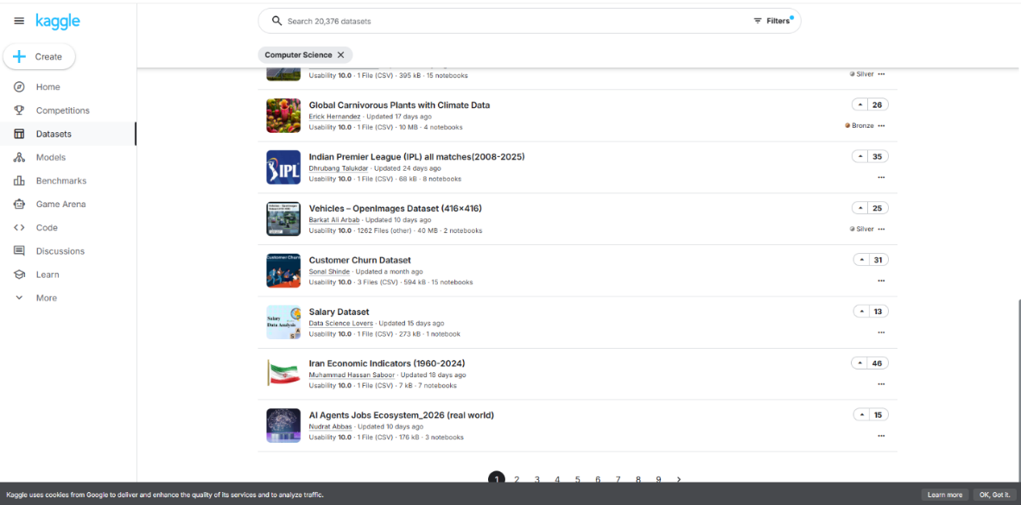
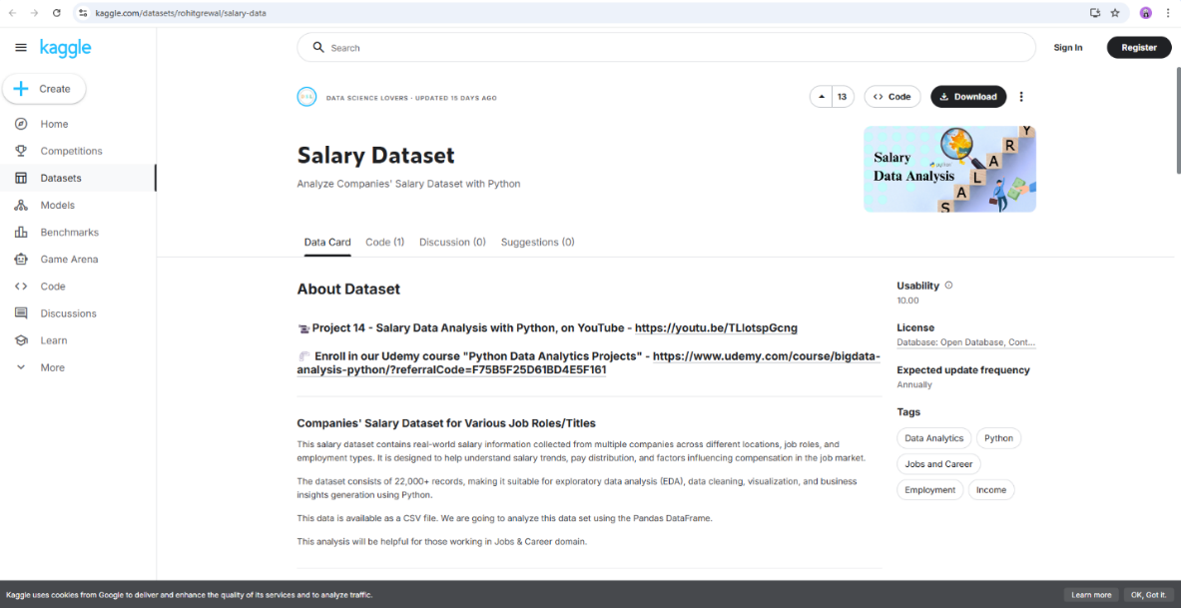
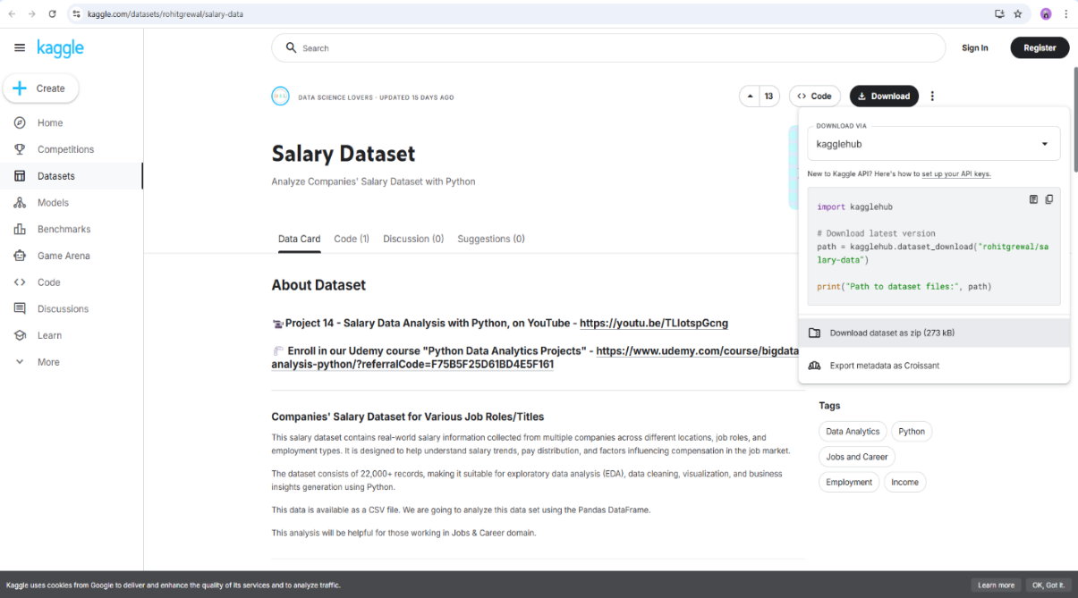
TASK: 1
Write a Python program that does the following:
- Create a list of integers entered by the user.
- Using a loop, go through each number in the list.
- For each number:
  - If the number is even, print "Even"
  - If the number is odd, print "Odd"
- At the end, print:
  - The total count of even numbers
  - The total count of odd numbers
INPUT
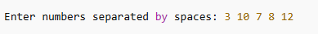
OUTPUT
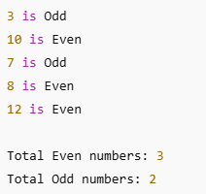
Step 1: Create a list of integers entered by the user
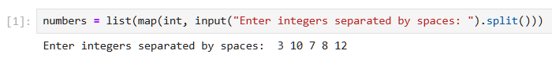
Step 2: Initialize counters
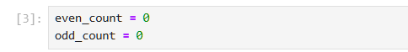
Step 3: Loop through each number and check
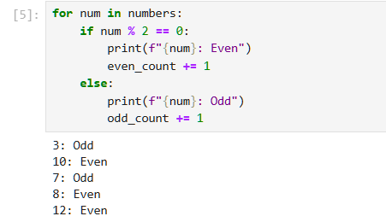
Step 4: Print totals
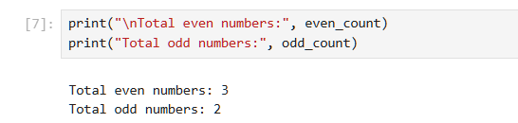
TASK-2
Take a two-digit number from the user and check whether it is a prime number or not.
If it is not a prime number, ask the user to enter another number and display the reverse of that number.
Step 1: Function to check if a number is prime
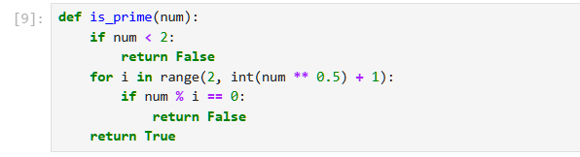
Step 2: Take a two-digit number from the user
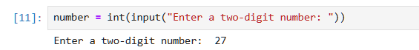
Step 3: Check if it's two-digit
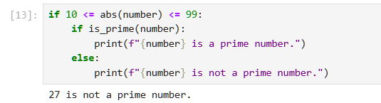
Step 4: Ask for another number and display its reverse
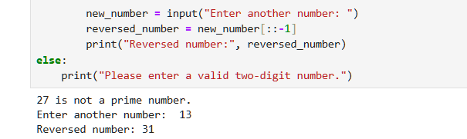
REFERENCE:
- https://www.youtube.com/watch?v=bP4JRwapoFc&list=PLyokmArqR3MkyH0fdvtUivctcK0ZT_FMa
- https://colab.research.google.com/#scrollTo=Wf5KrEb6vrkR
- https://www.google.com/search?q=how+to+collect+dataset&sca_esv=f845591e1947aef4&sxsrf=ANbL-n7pPNJcdjV0voUBBUdFcCK4atBNJA%3A1769581493457&ei=tat5aczTG63l7M8Pobz
KNIME INTRODUCTION
Introduction to KNIME
KNIME (Konstanz Information Miner) is an open-source data analytics, reporting, and integration platform designed to help users analyze and process data through a visual workflow interface. It enables users to perform complex data operations without requiring extensive programming knowledge, making it widely used in academic, research, and industrial environments.
Key Features of KNIME
One of the main strengths of KNIME is its visual programming approach, where users can drag and drop nodes to create workflows. This makes it especially useful for beginners while still being powerful enough for advanced users.
KNIME supports a wide range of functionalities, including:
- Data import from various sources (CSV, Excel, databases, etc.)
- Data cleaning and preprocessing
- Data transformation and manipulation
- Statistical analysis
- Machine learning and predictive modeling
- Data visualization and reporting
Another important feature is its extensibility. KNIME allows integration with programming languages such as Python and R, enabling users to combine visual workflows with custom code when needed.
KNIME Workflow Concept
A workflow in KNIME consists of a sequence of connected nodes, where each node performs a specific task. The output of one node becomes the input for the next node.
Basic components of a workflow include:
- Nodes: Individual processing units (e.g., CSV Reader, Math Formula, GroupBy)
- Ports: Input and output connectors on nodes
- Connections: Links that transfer data between nodes
This structure allows users to clearly visualize the data pipeline and understand each step of the analysis process.
Applications of KNIME
KNIME is widely used in multiple domains, such as:
- Business analytics (sales and revenue analysis)
- Healthcare (patient data analysis)
- Finance (risk analysis and forecasting)
- Marketing (customer segmentation)
- Retail (performance indicators and trend analysis)
It is particularly useful for handling large datasets and generating insights through descriptive and predictive analytics.
Advantages of KNIME
- User-friendly interface: No extensive coding required
- Open-source platform: Freely available for academic use
- Scalable and flexible: Suitable for small and large datasets
- Reproducible workflows: Easy to save, modify, and reuse
- Strong community support: Extensive documentation and tutorials
About Dataset
This dataset is synthetically generated to mimic weather data for classification tasks. It includes various weather-related features and categorizes the weather into four types: Rainy, Sunny, Cloudy, and Snowy. This dataset is designed for practicing classification algorithms, data preprocessing, and outlier detection methods.
Purpose and Utility
This dataset is useful for data scientists, students especially beginners, and practitioners to investigate classification algorithm's performance, practice data preprocessing, feature engineering, model evaluation, and test outlier detection methods
Practical Objectives
By completing this lab, students will gain practical experience in using KNIME for structured data analysis. Specifically, students will be able to:
- Import a CSV dataset into a KNIME workflow using the CSV Reader node.
- Examine and correct column data types to ensure computational accuracy.
- Generate descriptive statistical summaries to understand dataset characteristics.
- Create a calculated Revenue column using the Math Formula node.
- Compute four key retail performance indicators using GroupBy and Sorter nodes.
Procedure
Step 1: Download the Dataset
Obtain the Weather Classification Dataset in CSV format from the provided source and save it locally for analysis.
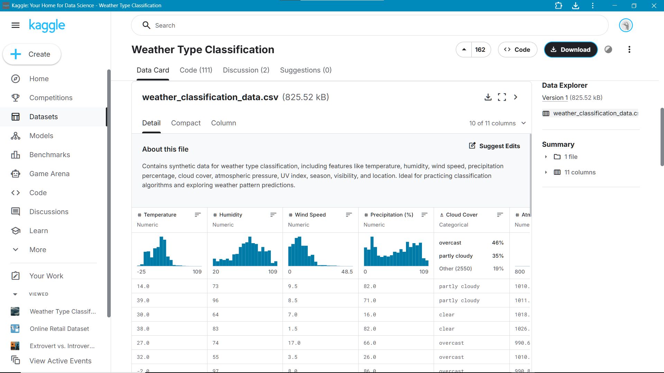
Step 2: Create new workflow
Create a New Workflow (File → New → New KNIME Workflow).
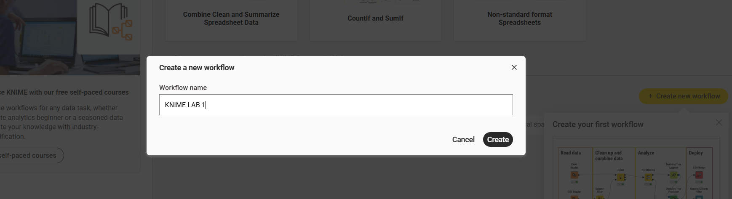
Step 3: Import the dataset
Use the CSV Reader node to load the online retail sales dataset into the workflow environment.
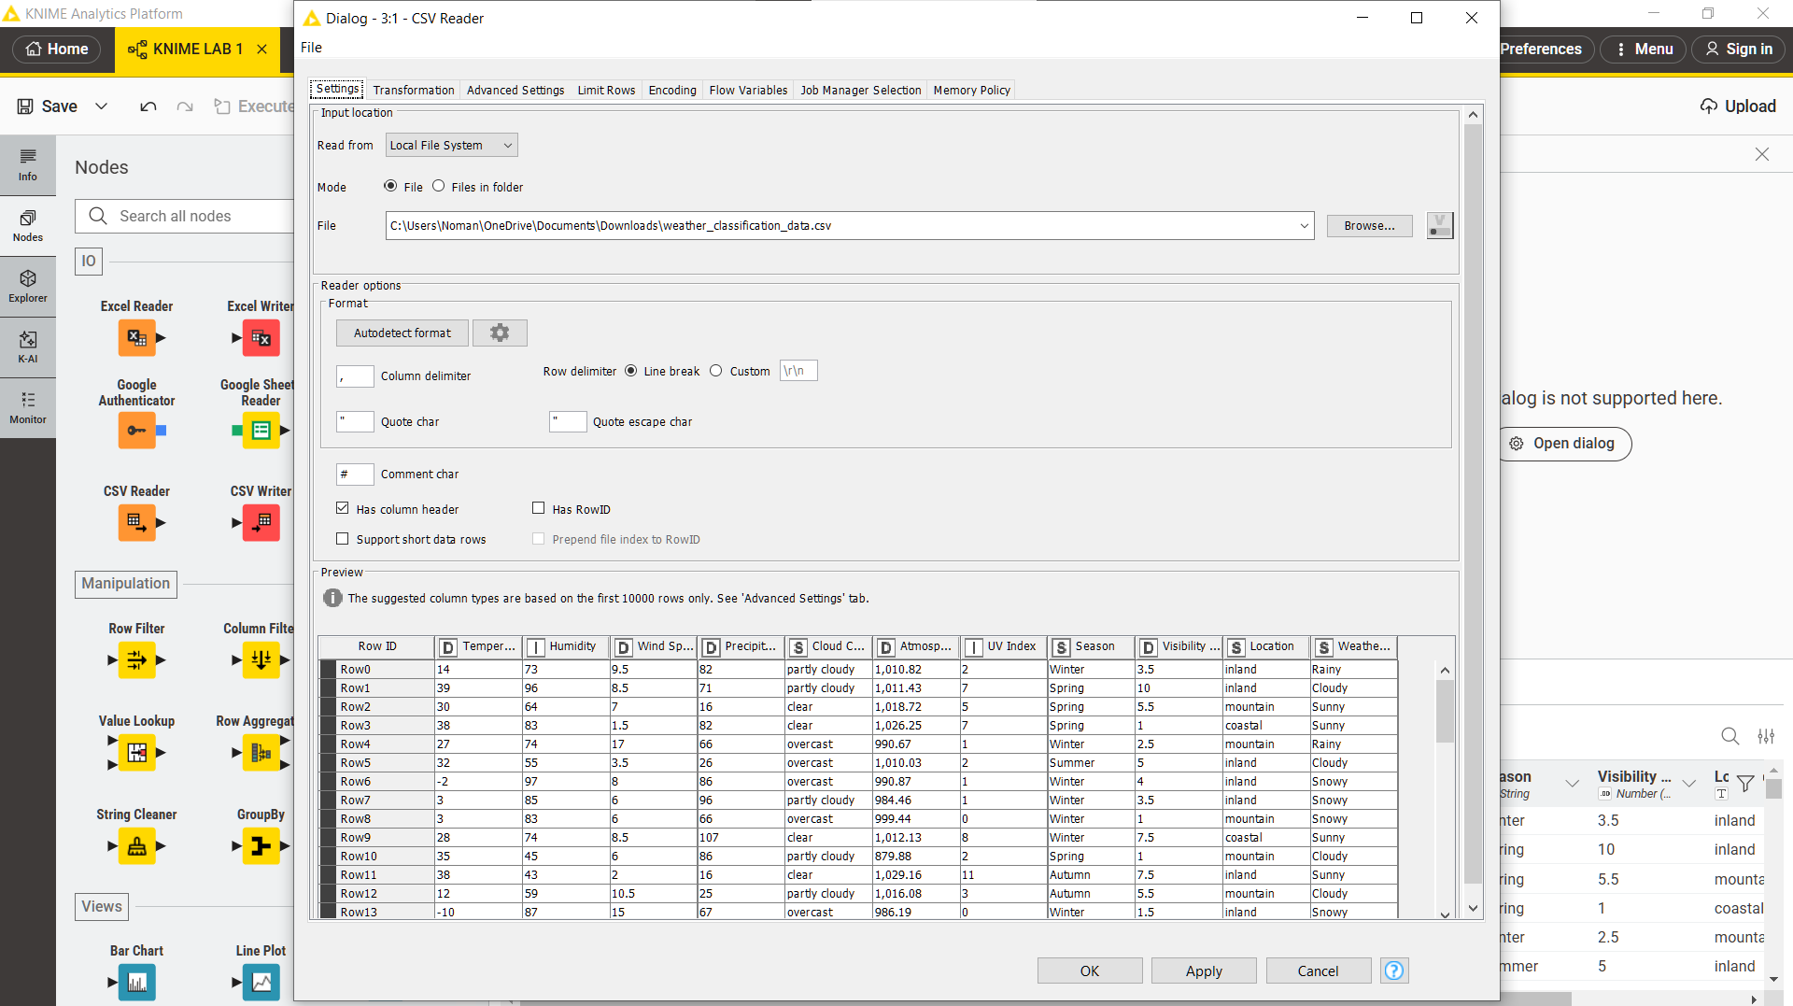
Step 4: Check Data Types
After loading data, check column types in the output table:
- String (text)
- Integer
- Double (decimal)
- Date/Time
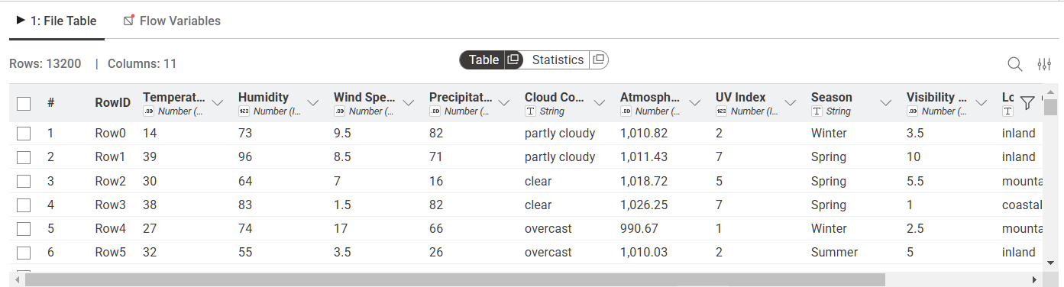
Step 5: Generate Descriptive Summary Statistics
Apply the Statistics node to compute descriptive measures such as mean, minimum, maximum, sum, and standard deviation for numeric attributes.
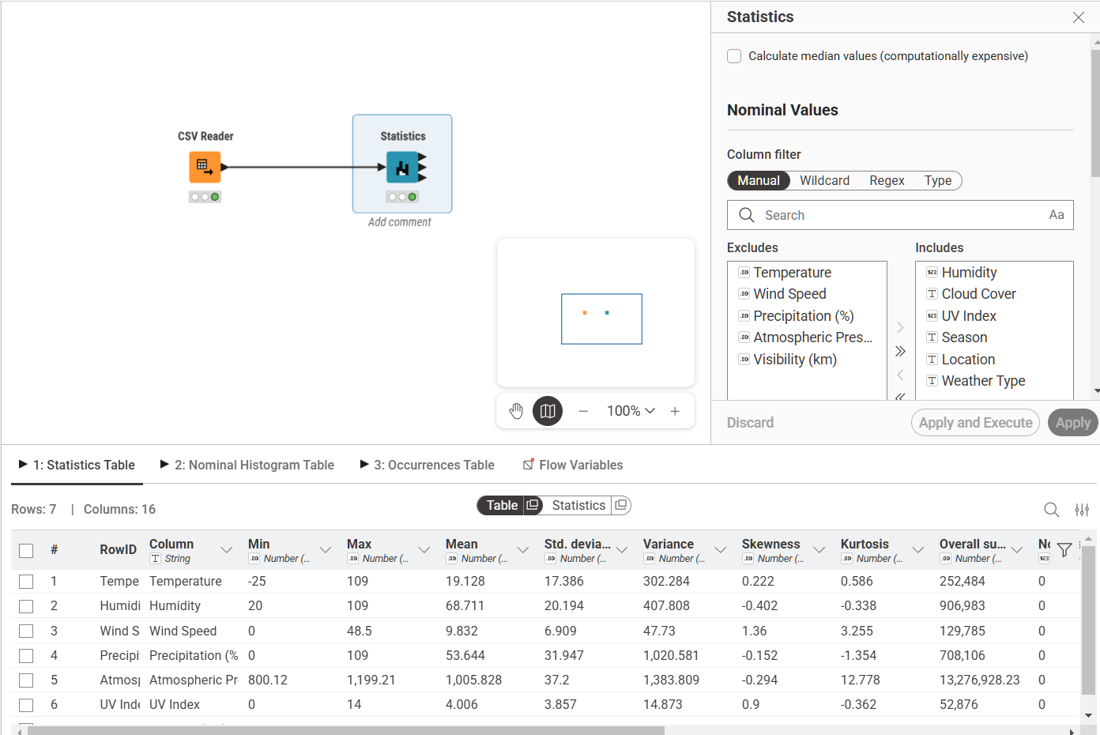
Step 6: Calculate Revenue Column
Add “Math Formula” node and connect it to your dataset.
- Revenue=Quantity×UnitPrice

LAB 02
Customer Churn Prediction
Real-World Problem
An e-commerce company wants to predict which customers are likely to stop using their service. Without early detection, the company loses revenue and cannot take retention action in time. This lab uses the CRISP-DM methodology and Orange Data Mining to build a churn prediction model on customer account data.
Dataset
The dataset used is Churn_Modelling.csv containing 10,000 customer records with 14 attributes. The target variable is Exited (1 = Churned, 0 = Retained). Key features include CreditScore, Geography, Gender, Age, Tenure, Balance, NumOfProducts, HasCrCard, IsActiveMember, and EstimatedSalary. Irrelevant columns RowNumber, CustomerId, and Surname were removed during preparation.
Software Environment (Orange Data Mining)
Orange is an open-source visual analytics platform that allows users to build data mining workflows by connecting widgets on a canvas. It supports data loading, preprocessing, classification, and evaluation without requiring any code.
Practical Objectives
- Load and inspect a CSV dataset using the File and Data Table widgets.
- Remove irrelevant columns and set the target variable using Select Columns.
- Normalize and encode features using the Preprocess widget.
- Train Logistic Regression and Random Forest classification models.
Procedure
Step 1: Load the Dataset
Use the File widget to load Churn_Modelling.csv and connect it to a Data Table widget to verify all 10,000 rows and 14 columns are loaded correctly.
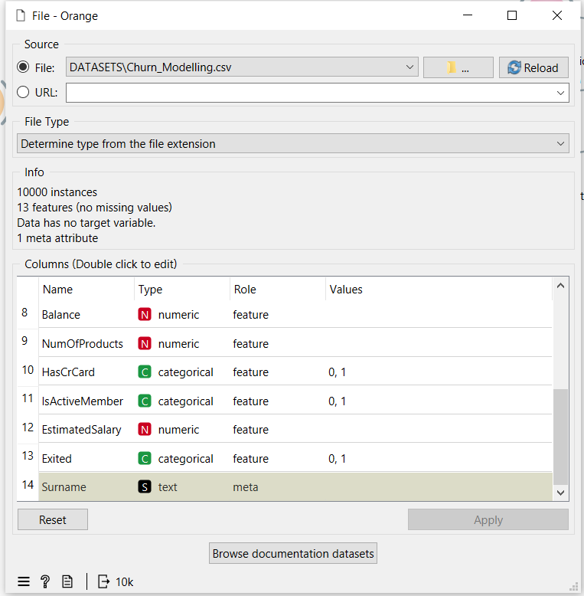
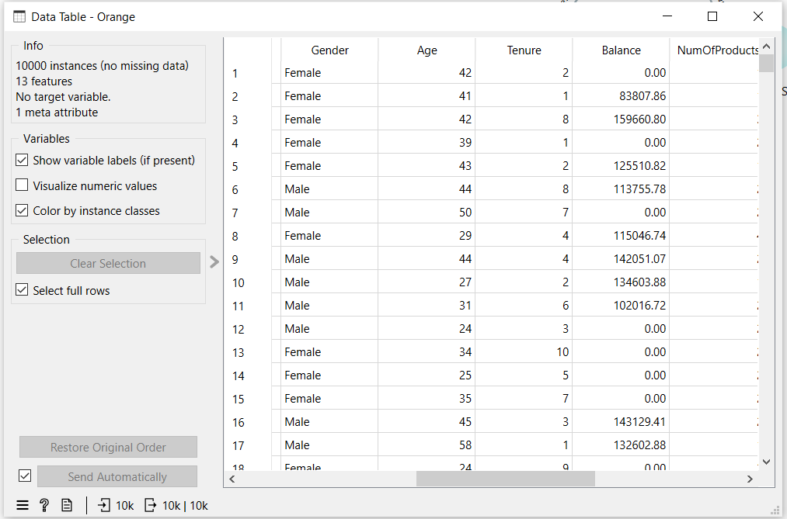
Step 2: Select Columns
Connect to a Select Columns widget. Move RowNumber, CustomerId, and Surname to the Ignore list. Set Exited as the Target class and keep all remaining features.
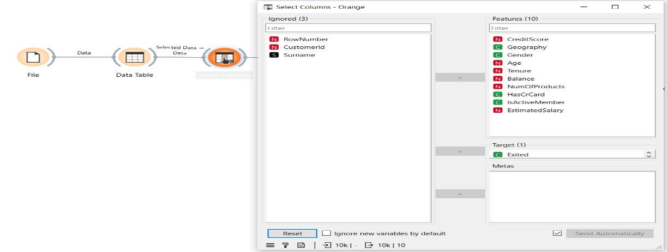
Step 3: Preprocess
Connect to a Preprocess widget and enable Min-Max normalization to scale all numeric features between 0 and 1.
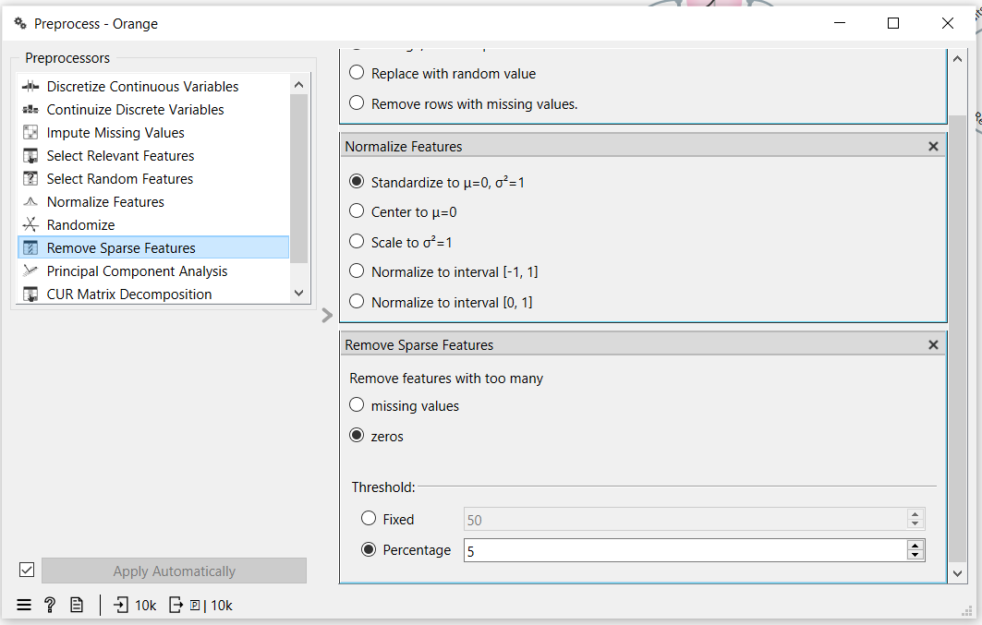
Step 4: Add Models
Connect the Preprocess widget to both a Logistic Regression widget and a Random Forest widget using the Preprocessor output port.
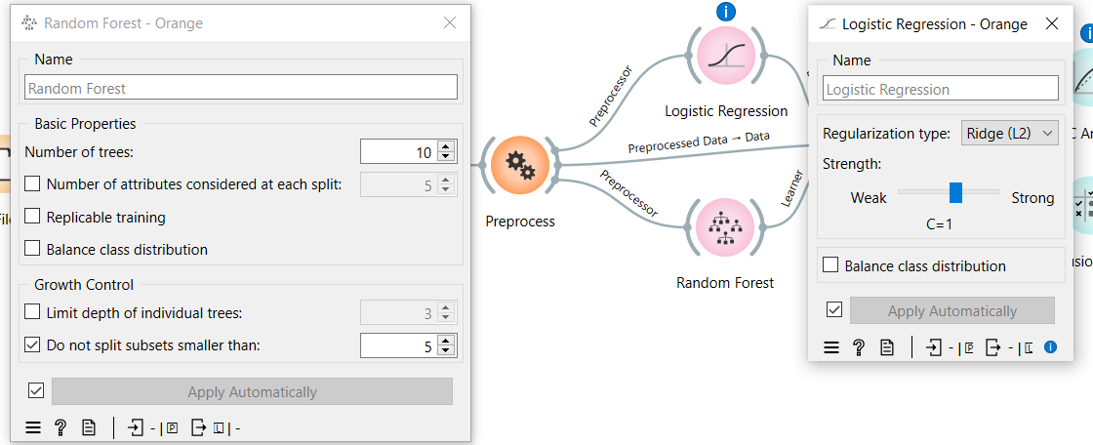
Step 5: Test and Score
Connect both learners and the preprocessed data to the Test and Score widget. Set evaluation to Cross Validation with 10 folds and enable Stratified splitting.
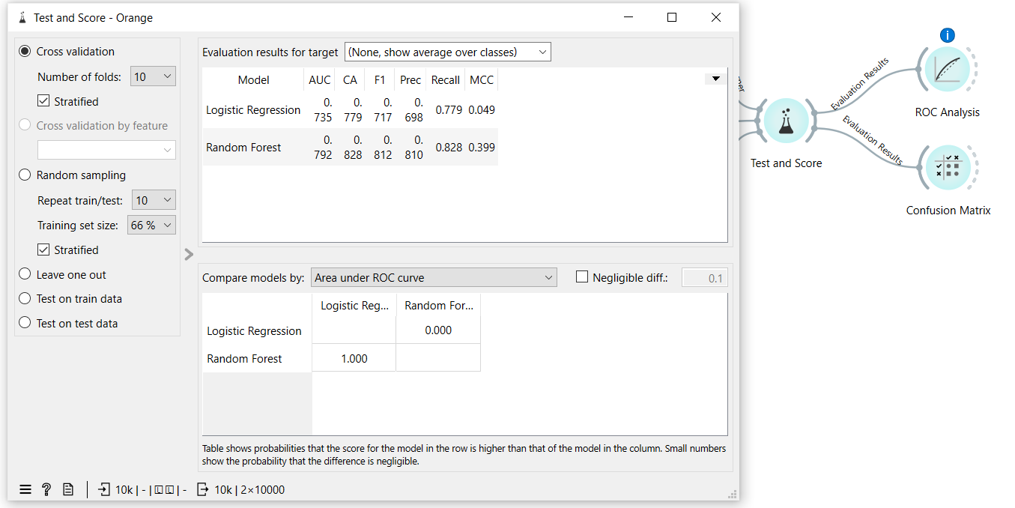
Step 6: Evaluate
Connect Test and Score to a ROC Analysis widget and a Confusion Matrix widget to visualize model performance.
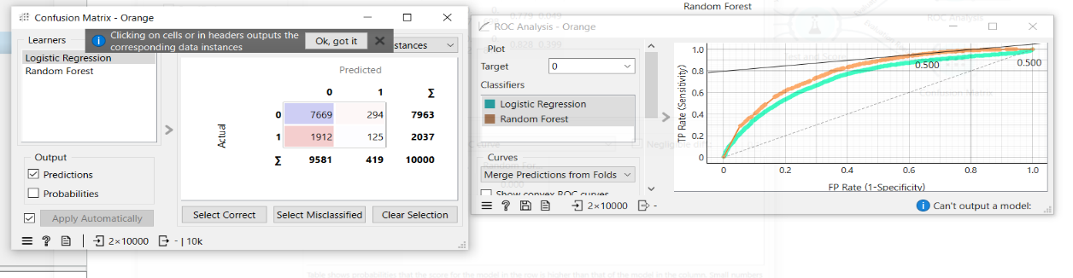

Outcome of the Lab
This lab demonstrates how raw customer data can be processed and modeled to predict churn using a complete CRISP-DM pipeline in Orange.
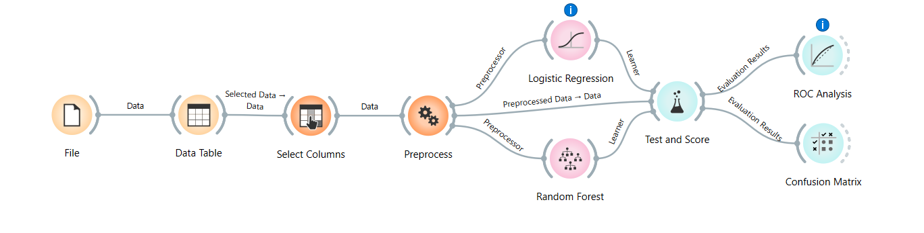
Random Forest outperformed Logistic Regression across all metrics. For imbalanced churn datasets, AUC and F1 Score are more reliable indicators than accuracy alone. The model can be deployed to score customers and trigger early retention actions for high-risk segments.

LAB 03
DATA CLEANING
Dataset Overview
The healthcare dataset contains patient-related information such as:
- Age
- Gender
- Medical conditions
- Test results
- Admission details
Characteristics:
- Structured dataset (CSV format)
- Contains missing values and inconsistencies
- May include duplicate patient records
- Used for healthcare analytics and decision-making
Real World Problem
Hospitals collect large volumes of patient data from different sources, which often contain missing values, duplicate records, and noisy or inconsistent entries. Such poor-quality data can lead to incorrect analysis and affect patient care decisions. Therefore, it is essential to clean and preprocess the data before using it for any analysis or predictive modeling. This lab focuses on improving data quality by handling missing values, removing duplicates, and filtering noise. The goal is to ensure reliable and accurate healthcare data.
Environment
- Jupyter Notebook / VS Code
- (Optional: RapidMiner Studio for GUI-based cleaning).
Objectives
- Handle Missing Values: Identify and resolve gaps in patient records.
- Remove Duplicates: Eliminate redundant entries to maintain data integrity.
- Noise Filtering: Resolve clinical noise by standardizing text and removing illogical numerical outliers.
- Calculate KPIs: Measure cleaning effectiveness through % Missing Reduced, Duplicate Removal %, and Data Quality Score.

Task Implementation
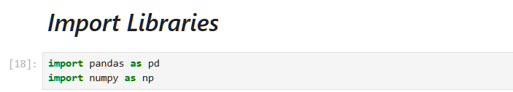

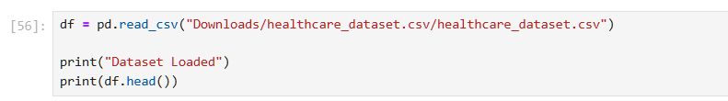
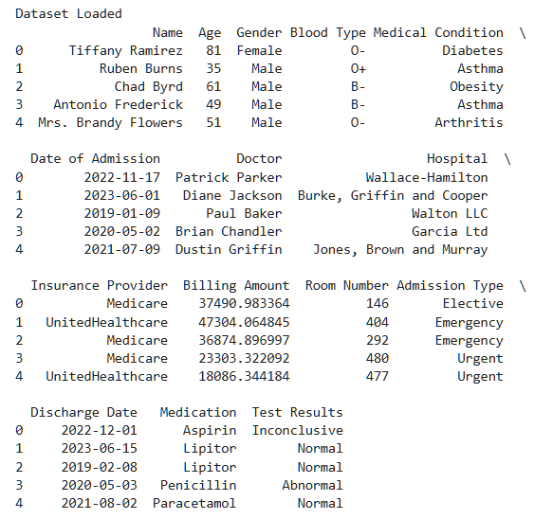

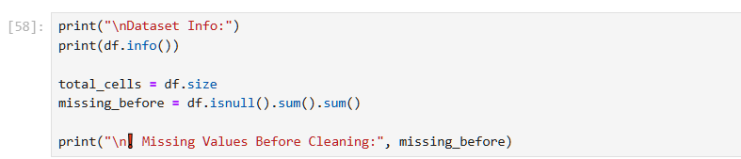
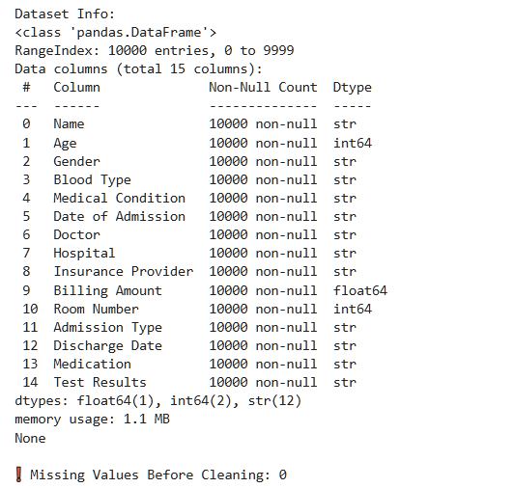
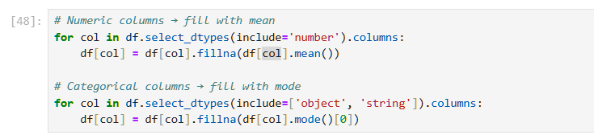

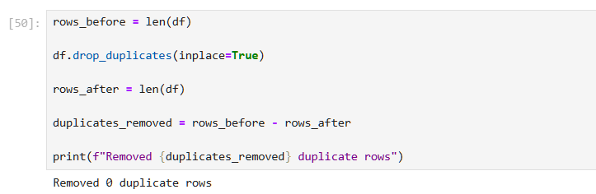
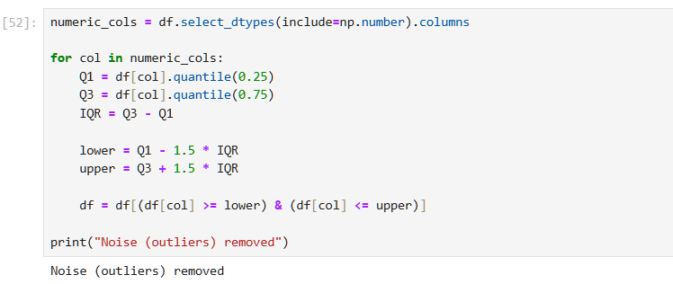

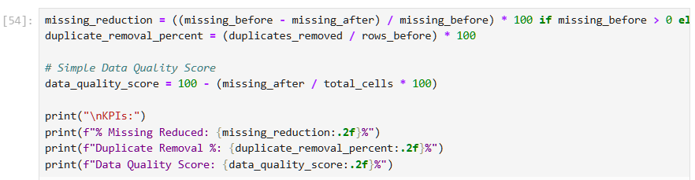
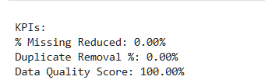
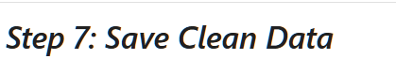
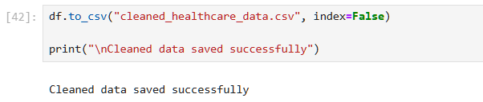

LAB 04
Data Preprocessing
Real-World Problem
A bank needs to assess loan risk before approving applications. Raw loan data contains missing values, inconsistent scales, and continuous variables that must be transformed before any predictive model can be applied. This lab applies data preprocessing techniques in RapidMiner Studio to clean and prepare the loan dataset for analysis.
Dataset
The dataset used is loan_dataset_20000.csv containing 20,000 loan application records. Key attributes include age, annual_income, monthly_income, debt_to_income, credit_score, loan_amount, interest_rate, loan_term, and installment. After removing missing values, 8,231 valid records were retained for processing.
Software Environment (RapidMiner Studio)
RapidMiner is a visual data science platform that allows users to build analytical workflows by connecting operators. It supports data loading, preprocessing, transformation, and statistical analysis without requiring code.
Practical Objectives
By completing this lab, students will be able to:
- Load a CSV dataset using the Retrieve operator.
- Handle missing values using the Replace Missing Values operator.
- Normalize numeric features using Z-Score normalization.
- Apply Z-Score Peak Transformation to handle outliers.
- Discretize continuous variables into categorical bins.
- Generate summary statistics using the Statistics operator.
- Calculate Variance Reduction and Distribution Improvement as KPIs
Lab Exercise
Step 1: Load the Dataset
Use the Retrieve operator to load loan_dataset_20000.csv into the workflow. Connect it to the next operator to begin preprocessing.
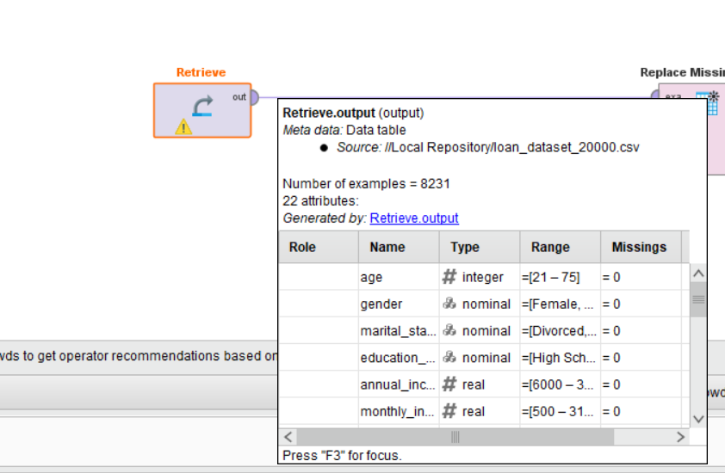
Step 2: Replace Missing Values
Connect to a Replace Missing Values operator. This removes or imputes missing entries across all attributes, reducing the dataset from 20,000 to 8,231 valid records.
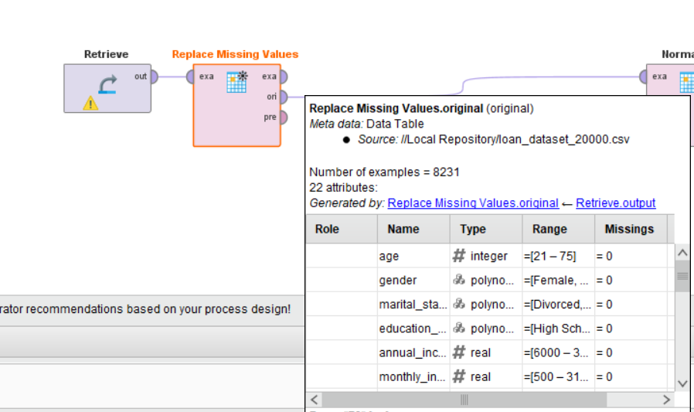

Step 3: Normalize
Connect to a Normalize operator and apply Z-Score normalization. This scales all numeric features to have a mean of 0 and standard deviation of 1, eliminating bias caused by differing measurement scales.
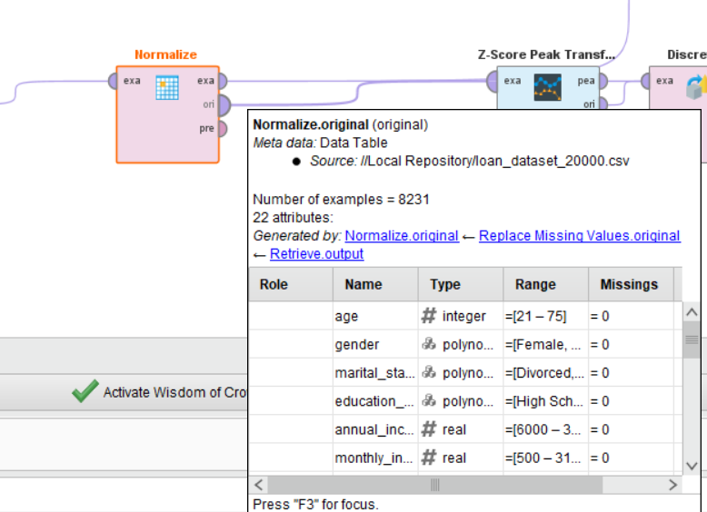
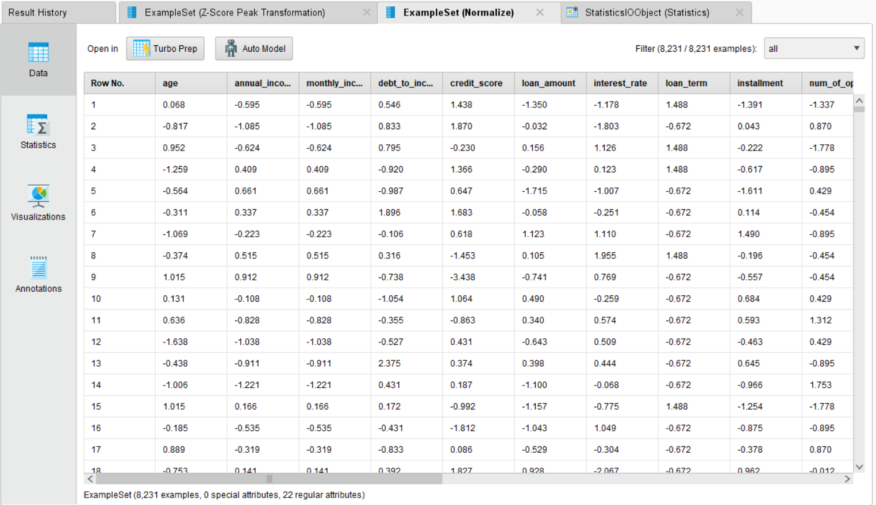
Step 4: Z-Score Peak Transformation
Connect to a Z-Score Peak Transformation operator. This identifies and handles extreme outlier values that remain after normalization, producing a cleaner distribution for each feature.
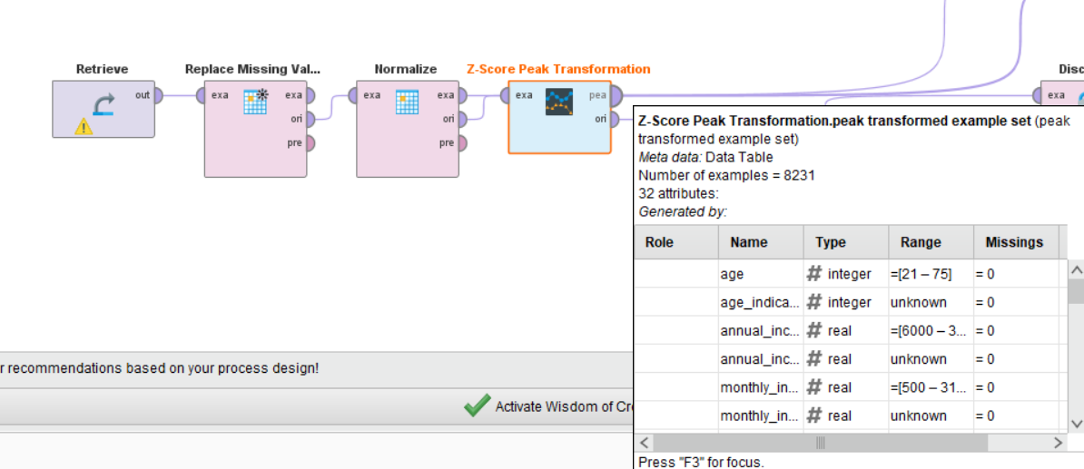
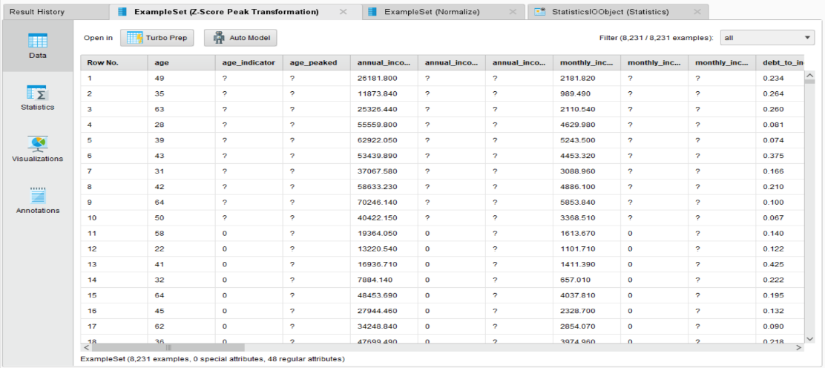
Step 5: Discretize
Connect to a Discretize operator. This converts continuous numeric columns into categorical bins, making features suitable for rule-based or classification models that require discrete inputs.
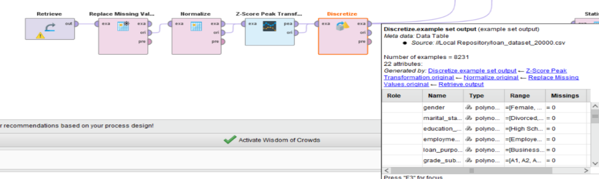
Step 6: Generate Statistics
Connect all result outputs to a Statistics operator. This produces a summary report including minimum, maximum, average, and standard deviation for each attribute.
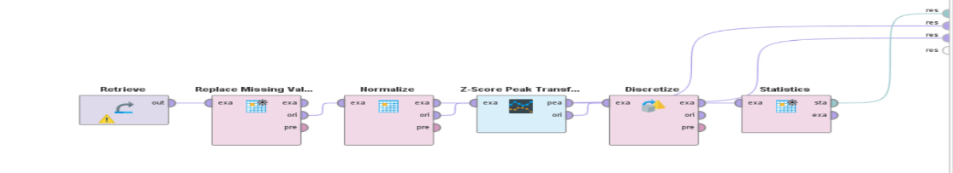
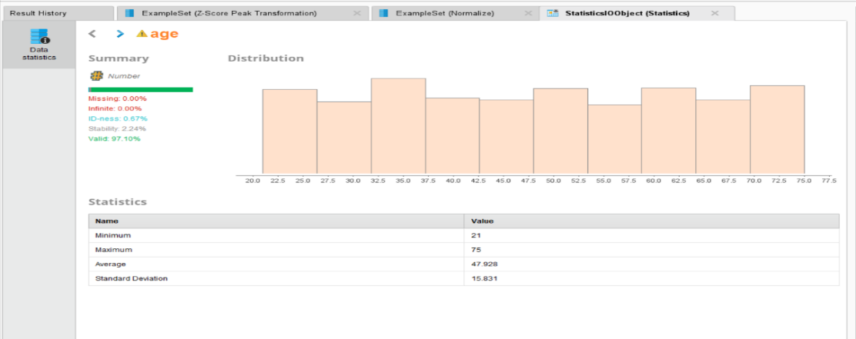

LAB 05
Market Basket Analysis
Dataset Overview
Market Basket Analysis was performed on a grocery dataset to identify relationships between items. Support, confidence, and lift were calculated manually and validated using the Apriori algorithm. The analysis revealed meaningful product associations useful for retail decision-making.
The dataset contains customer transactions where each row represents a list of items purchased together.
Real World Problem
Retail stores generate large volumes of transaction data but often lack clear insights into customer purchasing behavior. They face difficulty in identifying which products are frequently bought together, leading to missed opportunities for cross-selling and effective promotions This problem focuses on analyzing transaction data to discover meaningful associations between items using market basket analysis. The goal is to support better business decisions and improve overall sales performance.
Software Environment
- Python: Specifically utilizing Pandas for data manipulation and transactional grouping.
- Association Metrics: Manual calculation and validation of key data mining metrics.
Objectives
- Frequent Itemsets: Identify products that appear most often in customer baskets.
- Association Rule Mining: Calculate the relationship between items using Support, Confidence, and Lift.
- Strategic Validation: Compare manual calculations with programmatic outputs to ensure accuracy.
- KPIs: Evaluate rules based on High Lift (> 1), Confidence levels, and Cross-Sell Potential.
Task Implementation

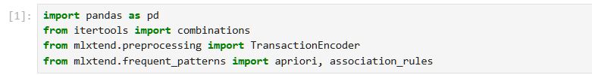

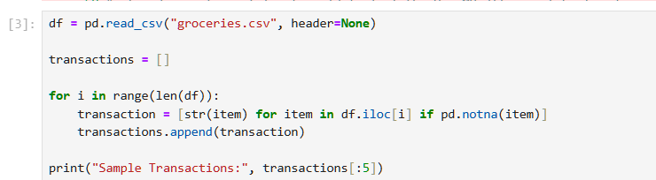
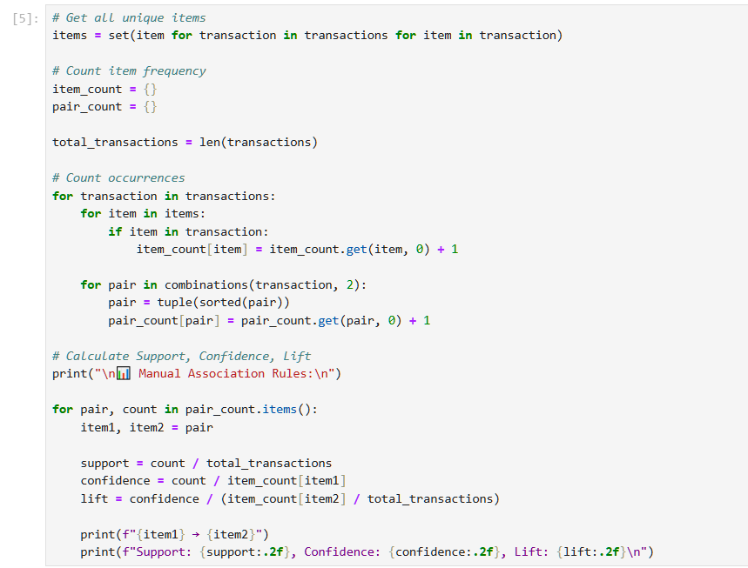
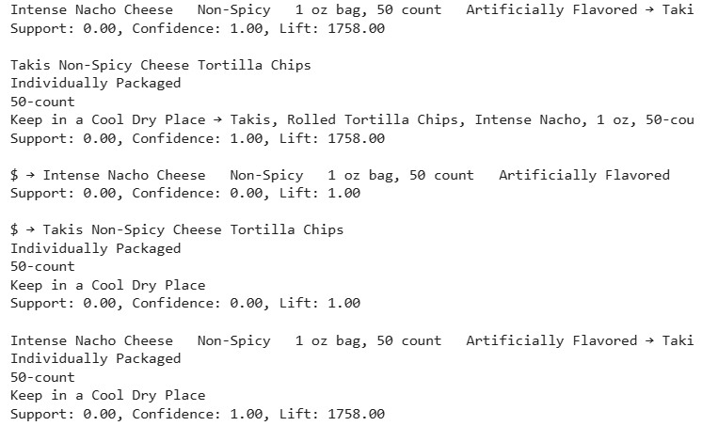

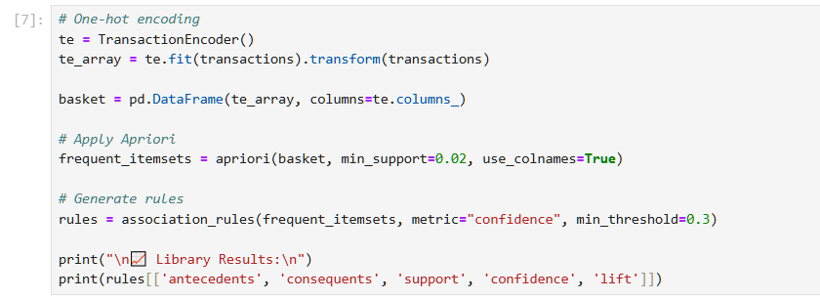
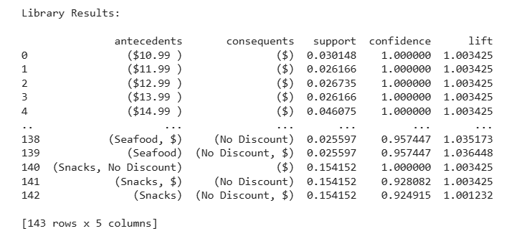

LAB 06
Apriori Algorithm (Product Combination Analysis)
Dataset Overview
The Grocery dataset contains transactional data, where each row represents items purchased together in a single shopping visit.
Key Features
- Categorical data.
- Variable number of items per transaction.
- Used for market basket analysis.
Real World Problem
Retail stores and supermarkets collect large amounts of transaction data but struggle to answer:
“Which products are frequently bought together?”
Without this insight:
- Cross-selling opportunities are missed.
- Store layout is inefficient.
- Promotions are less effective.
Software Environment
- Python: Utilizing Pandas for data transformation and basket encoding.
- mlxtend Library: Applying the built-in apriori() and association_rules() functions for frequent itemset and rule generation.
Objectives
Use the Apriori algorithm to:
- Find frequent item combinations.
- Generate association rules.
- Improve business decisions.
Task Implementation
Import Libraries:
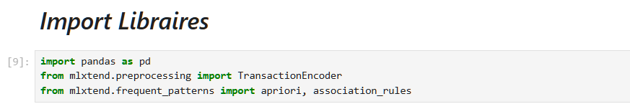

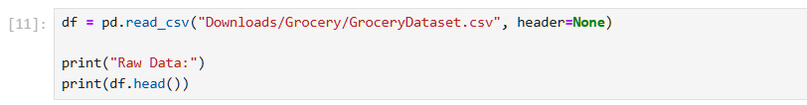
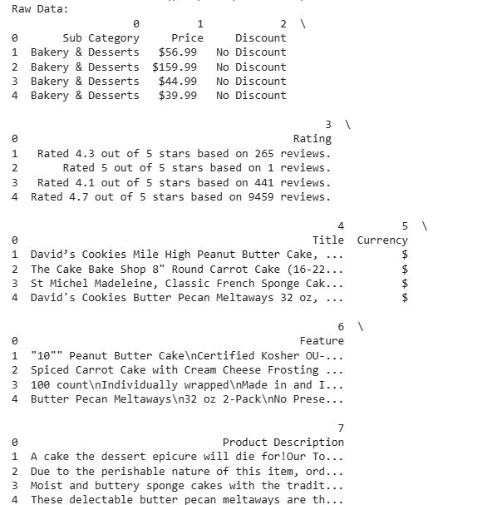

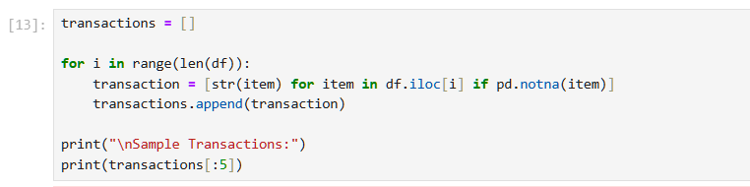
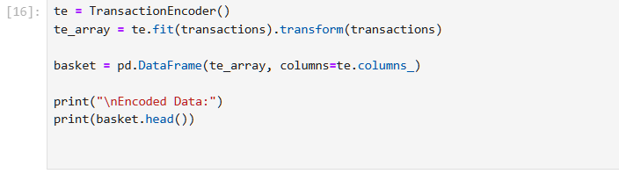
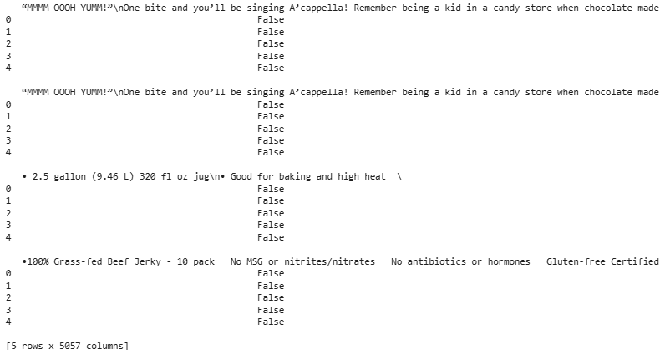

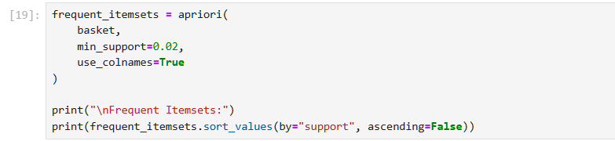
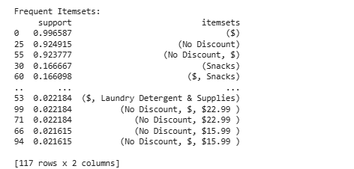
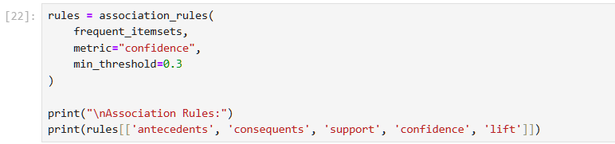
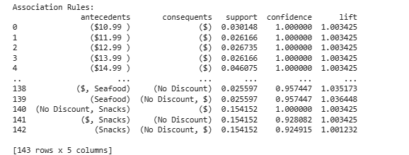

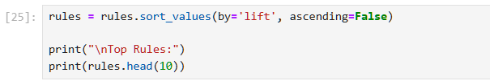
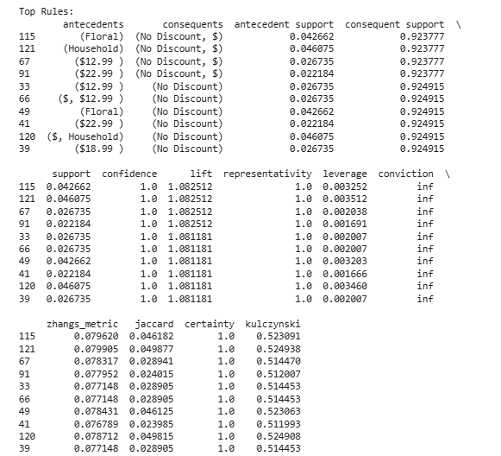

LAB 07
FP-Growth (Efficient Frequent Pattern Mining)
Dataset Overview
The Grocery Store dataset represents customer purchasing behavior in a retail supermarket. Each record in the dataset corresponds to a single transaction (basket), containing a list of items purchased together by a customer during one visit.
This dataset is widely used for market basket analysis, where the goal is to identify relationships between products based on co-occurrence in transactions.
Real World Problem
Retail stores face challenges in understanding customer purchasing patterns from large volumes of transaction data. This lab addresses the problem by analyzing grocery transactions to identify frequently bought item combinations. Using FP-Growth, businesses can uncover hidden relationships between products, enabling better product placement, cross-selling, and marketing strategies.
Software Environment
- Python: Utilizing Pandas for data transformation and one-hot encoding.
- mlxtend Library: Applying apriori(), fpgrowth(), and association_rules() functions for performance comparison and rule generation.
Practical Objectives
- FP-Tree Construction: Build a compressed FP-Tree from the transaction matrix for efficient pattern mining.
- Performance Comparison: Measure and compare execution time between FP-Growth and Apriori at the same support threshold.
- Association Rule Mining: Extract rules from FP-Growth results using Lift as the primary metric.
- KPIs: Evaluate both algorithms on Execution Time, Rule Count, and Efficiency Gain.
Task Implementation
Import Libraires:
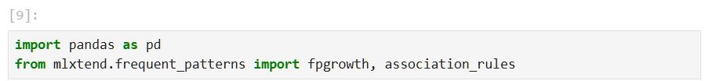


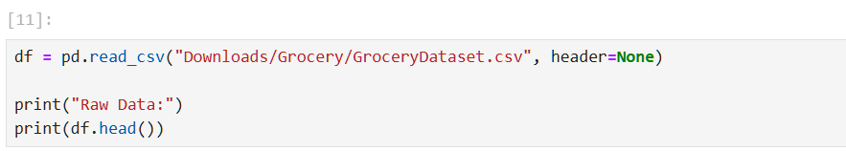
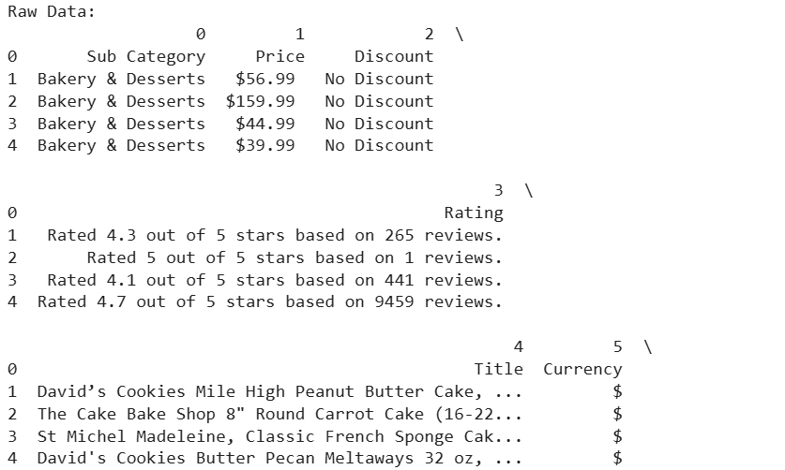
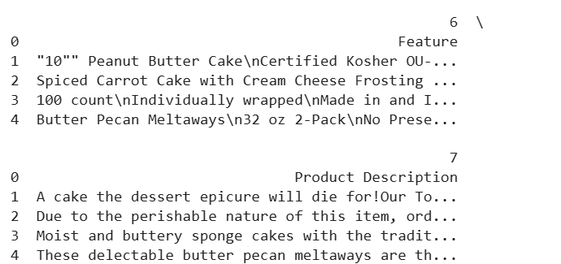

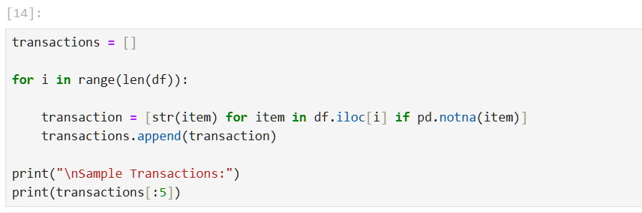

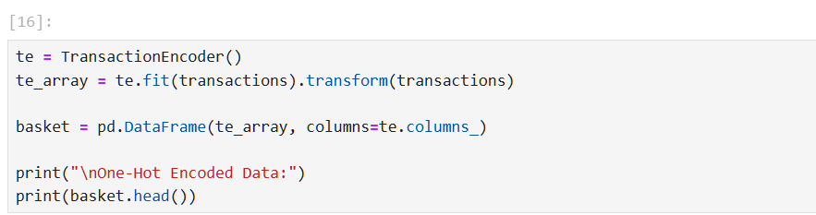
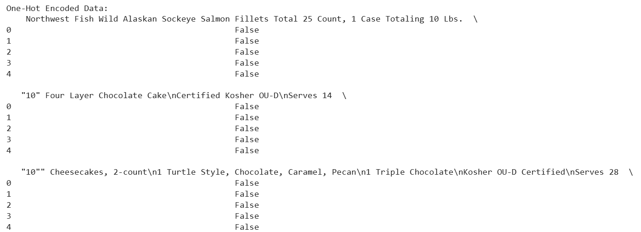
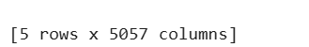

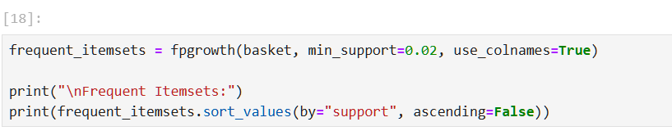
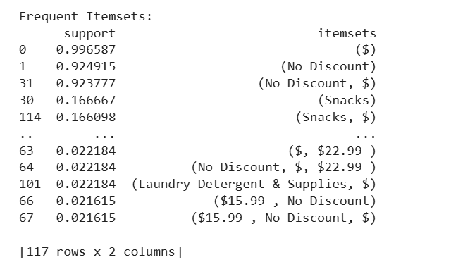

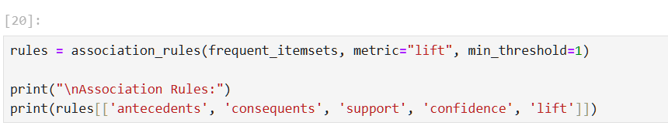
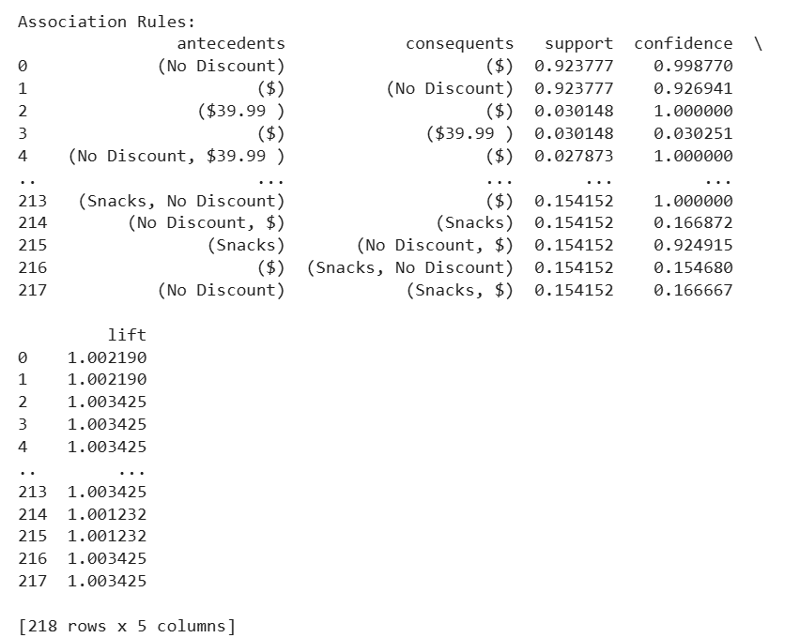

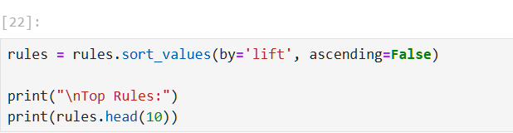
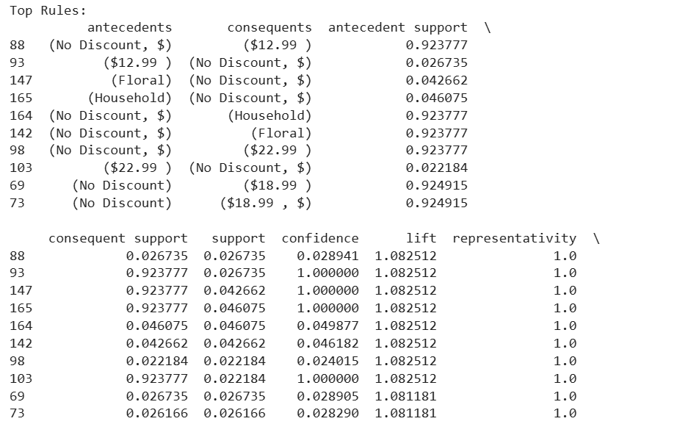
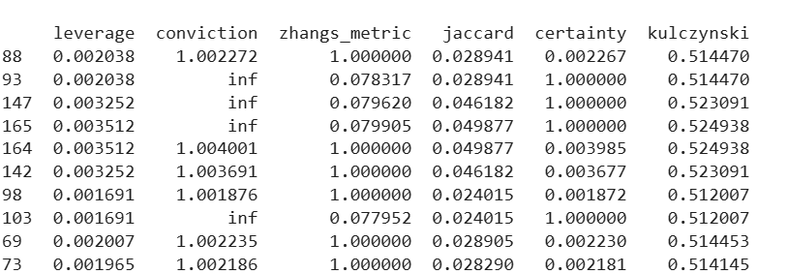

LAB 08

Python Basics (Reusable Data Processing Module)

Python in Artificial Intelligence (AI)
- Artificial Intelligence (AI) enables machines to simulate human intelligence such as learning, reasoning, and decision-making.
- Python is the most widely used programming language in AI due to its simplicity and powerful libraries.
Why Python is Used in AI
- Simple and readable syntax.
- Large collection of AI libraries.
- Strong community support.
- Platform independent.
- Rapid development and prototyping.
Role of Python in AI
- Data preprocessing and analysis.
- Feature extraction.
- Model training and testing.
- Prediction and decision-making.
- Visualization of results
Important Python Libraries for AI
NumPy
- Used for numerical computations.
- Supports multi-dimensional arrays and matrices.
- Fast mathematical operations
import numpy as np
Pandas
- Used for data manipulation and analysis.
- Handles large datasets efficiently.
import pandas as pd
Matplotlib & Seaborn
- Used for data visualization.
- Helps understand patterns and trends.
import matplotlib.pyplot as plt
import seaborn as sns
Scikit-learn
- Provides machine learning algorithms.
- Used for classification, regression, and clustering.
from sklearn.model_selection import train_test_split
TensorFlow
- Used for deep learning and neural networks.
import tensorflow as tf
PyTorch
- Popular for research and deep learning applications.
import torch
OS Library
- Used for file and directory handling.
import os
Applications of Python in AI
- Speech recognition.
- Face and emotion recognition.
- Chatbots and virtual assistants.
- Recommendation systems.
- Medical diagnosis.
- Autonomous vehicles
Advantages of Python in AI
- Easy integration with other languages.
- Large ecosystem of tools and frameworks.
- Suitable for both beginners and professionals.
- Open-source and cost-effective.
Limitations of Python in AI
- Slower execution compared to C/C++.
- High memory consumption.
- Not ideal for mobile applications directly.
Dataset Overview
This dataset is crafted to practice data cleaning and preprocessing techniques in machine learning. It contains 157 rows of student admission records, including duplicate rows, missing values, and some data inconsistencies (e.g., outliers, unrealistic values). It’s ideal for practicing common data preparation steps before applying machine learning algorithms.
The dataset simulates a university admission record system, where each student’s admission profile includes test scores, high school percentages, and admission status. The data contains realistic flaws often encountered in raw data, offering hands-on experience in data wrangling.
Real-World Problem
Universities and colleges receive thousands of applications every year. Each application includes various attributes such as:
- Academic scores (GPA, test scores like GRE/SAT)
- Extracurricular activities
- Work experience
- Statement of purpose strength
- Recommendation letters
However, this data is often:
- Spread across different formats (CSV, forms, databases)
- Incomplete (missing values)
- Inconsistent (different scales, formats)
- Difficult to process manually
Software Environment
The implementation was carried out using Python 3.x with Pandas and NumPy libraries in a Jupyter Notebook environment on a Windows-based system. The dataset was sourced from Kaggle and processed in CSV format.
Practical Objectives
- Class Creation: Encapsulate data loading, statistics, encoding, and normalization into a single reusable class.
- Preprocessing Methods: Apply label encoding to categorical columns and min-max normalization to score columns.
- Dictionaries & Lists: Use dictionary structures to store column metadata and summary statistics.
- KPIs: Evaluate the module on Code Efficiency and Reusability.
Task Implementation
Step 1: Import Libraries
Pandas and NumPy libraries are imported for data handling and numerical operations.
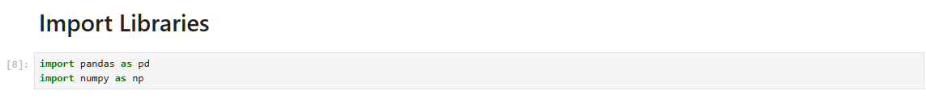
Step 2: Class Creation (DataProcessor)
A class is defined to organize all data processing tasks into reusable methods.
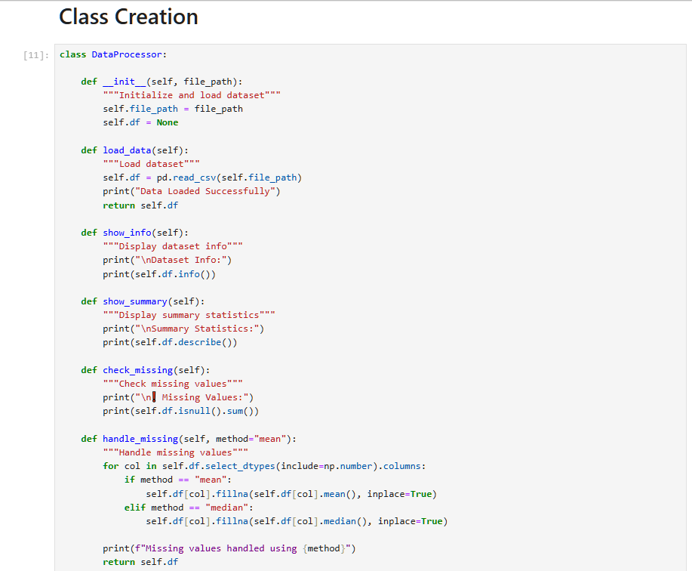
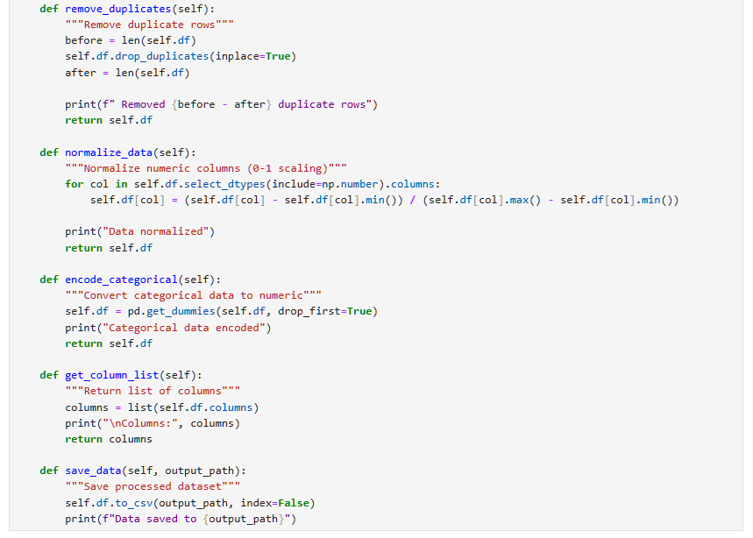
Step 3: CSV file path
Give file path to perform preprocessing tasks.
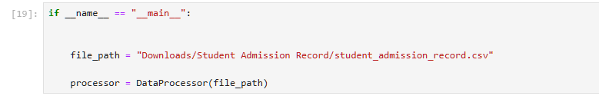
Step 3: Load Dataset
The dataset is loaded from a CSV file using the load_data() function.
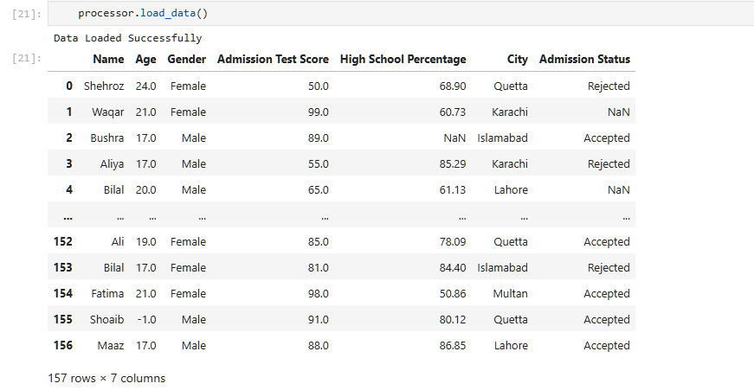
Step 4: Display Dataset Information
The show_info() method displays structure, data types, and non-null values.
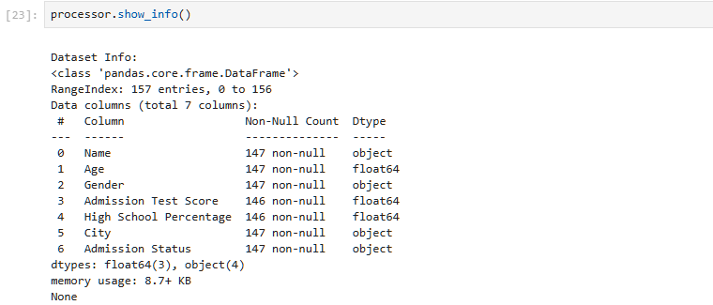
Step 5: Generate Summary Statistics
The show_summary() function provides statistical measures like mean, min, max, and standard deviation.
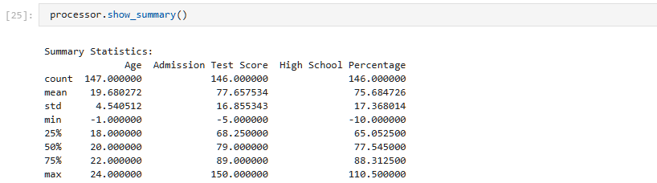
Step 6: Check Missing Values
The check_missing() function identifies missing data in each column.
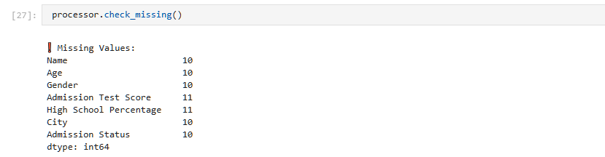
Step 7: Handle Missing Values
Missing values are filled using mean or median through handle_missing().
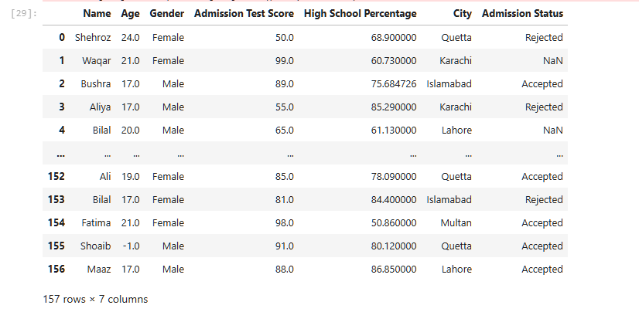
Step 8: Remove Duplicates
Duplicate rows are removed using remove_duplicates() to improve data quality.
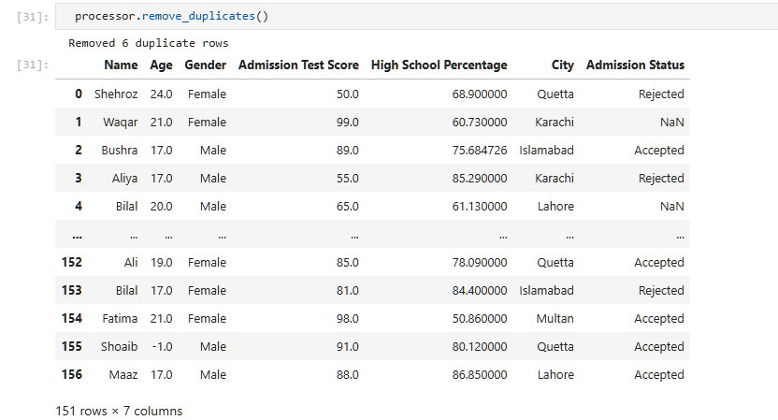
Step 9: Encode Categorical Variables
Categorical data is converted into numerical format using encode_categorical().
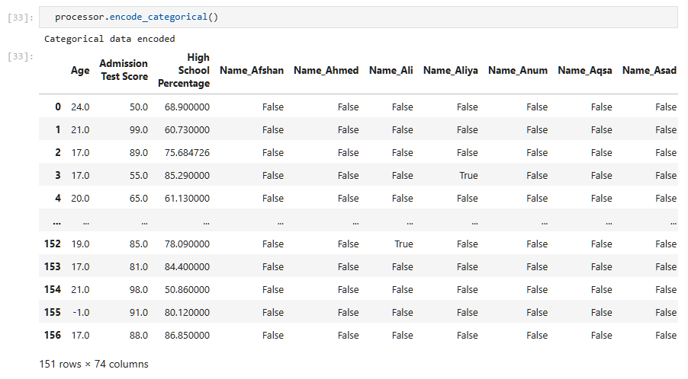
Step 10: Normalize Data
Numeric values are scaled between 0 and 1 using normalize_data().
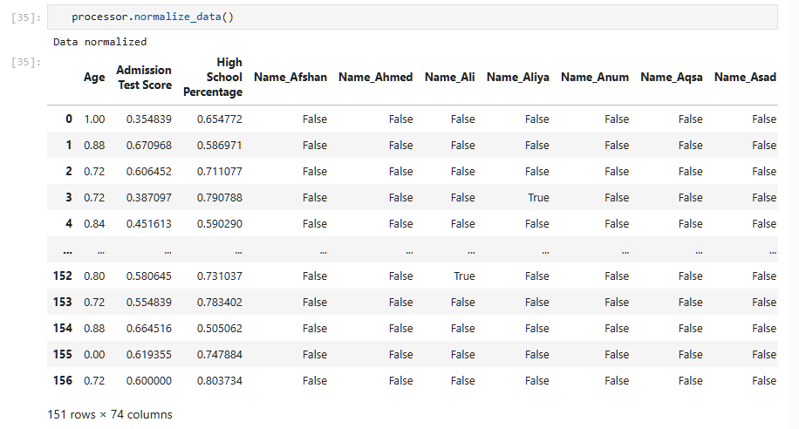
Step 11: Display Column Names
The get_column_list() function lists all dataset columns.
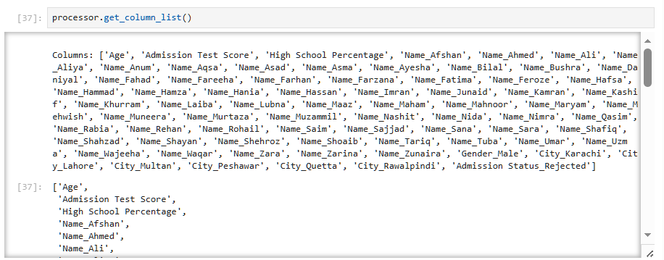
Step 12: Save Processed Data
The cleaned and processed dataset is saved to a new CSV file using save_data().

LAB 09
Decision Tree Classifier
Real-World Problem
Scenario: A marketing company wants to predict whether a customer will purchase a product based on demographic and behavioral data.
Business Goal: Identify likely buyers so marketing campaigns can target the right customers and reduce advertising costs.
Features:
- Age
- Gender
- Income
- Previous purchases
- Website visits
- Spending score
Target Variable: Purchased (Yes/No)
Dataset Description
Use a Marketing / Customer Purchase Dataset from Kaggle.
Column | Description
Age | Customer age in years
Gender | Male/Female
Income | Annual income
Previous_Purchases | Number of past purchases
Website_Visits | Visits in the last month
Purchased | Target variable (0 = No, 1 = Yes)
Practical Objectives
- Load and inspect the dataset.
- Preprocess categorical and numerical features.
- Train a Decision Tree classifier.
- Visualize the decision tree.
- Evaluate model performance using Accuracy, Precision, Recall, and F1-score.
Procedure:
Step 1: Import Libraries
Import the required Python libraries for data handling, modeling, visualization, and evaluation.
- pandas handles the dataset.
- train_test_split divides data into training and testing sets.
- DecisionTreeClassifier builds the model.
- plot_tree visualizes the tree structure.
- classification_report gives evaluation metrics.
Step 2: Load the Dataset
Read the CSV file into a DataFrame.
head() displays the first five rows so you can verify the data loaded correctly.
Step 3: Explore the Data
Check the structure, data types, and missing values.
- info() shows column types and non-null counts.
- describe() provides summary statistics for numerical columns.
- isnull().sum() counts missing values in each column.
Step 4: Prepare Features and Target
Separate the target variable and convert categorical variables into numeric form.
- X contains the input features.
- y contains the target labels.
- get_dummies() converts text categories into numerical columns.
Step 5: Split the Dataset
Use 80% of the data for training and 20% for testing.
The model learns from X_train and y_train, while X_test and y_test are used for evaluation.
Step 6: Train the Decision Tree Model
Create and fit the classifier.
- max_depth=4 limits tree complexity to reduce overfitting.
- fit() trains the model on the training data.
Step 7: Make Predictions
Predict the target labels for the test set. The model uses learned decision rules to classify each customer as a purchaser or non-purchaser.
Step 8: Evaluate the Model
Generate performance metrics and a confusion matrix.
- Accuracy: Overall correct predictions.
- Precision: How many predicted buyers were actually buyers.
- Recall: How many actual buyers were correctly identified.
- F1-score: Balance between precision and recall.
Step 9: Visualize the Decision Tree
Display the tree structure for interpretation. The tree diagram shows which features and thresholds are used to make predictions.
Code Implementation
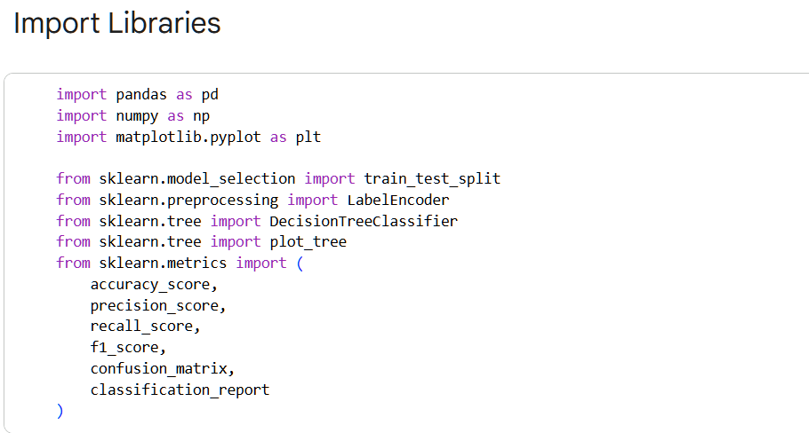
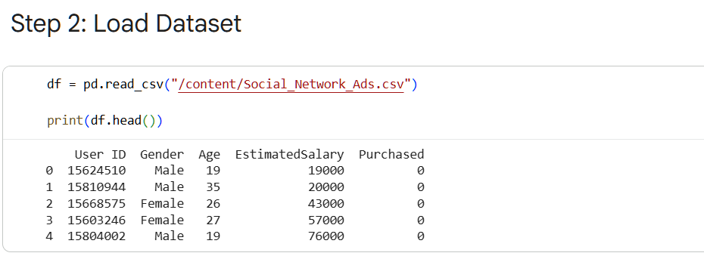
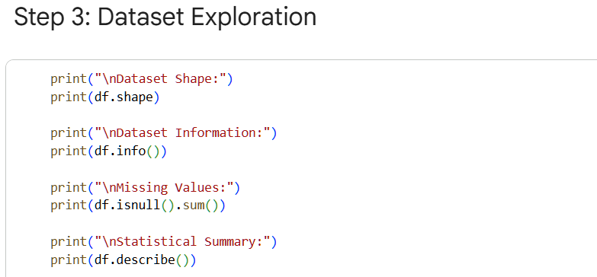
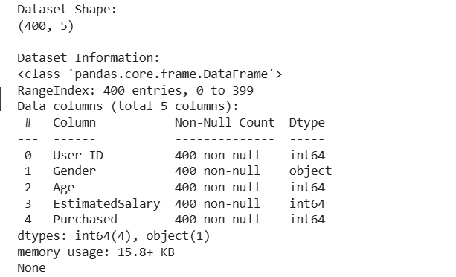
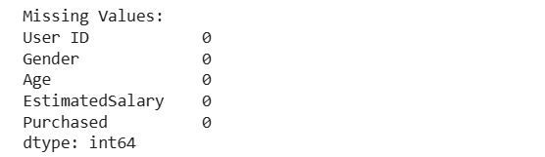
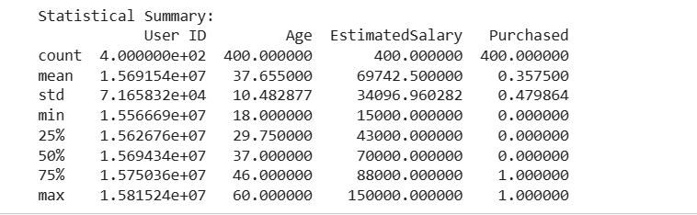
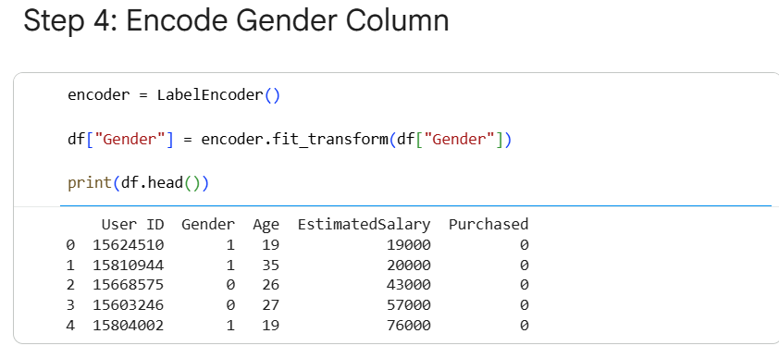
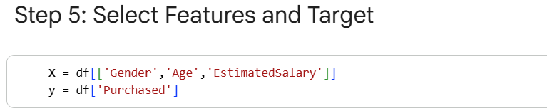
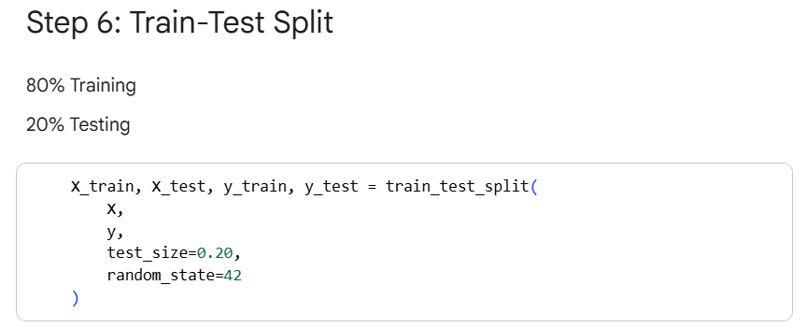
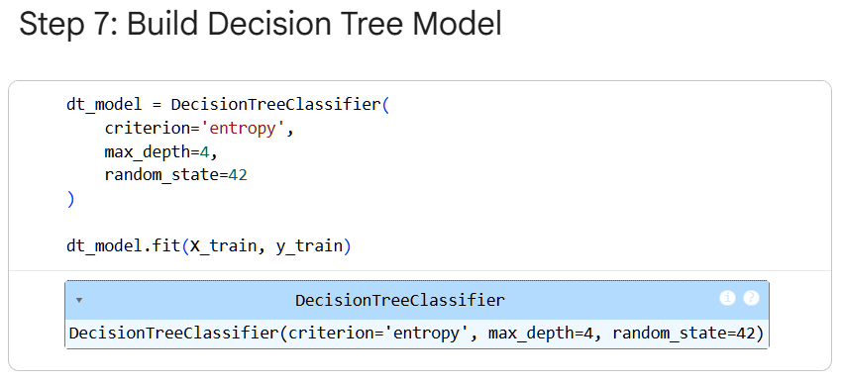
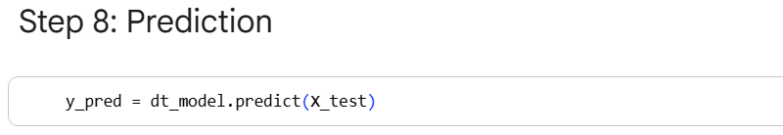
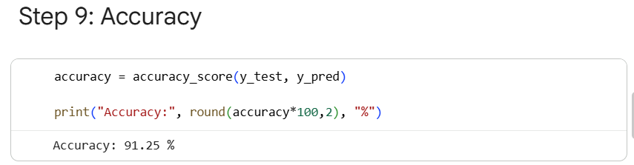
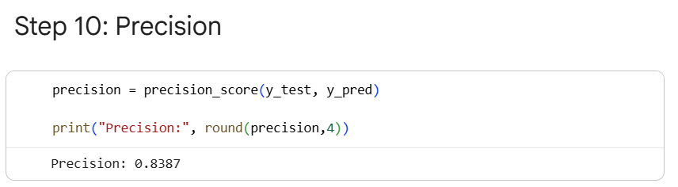
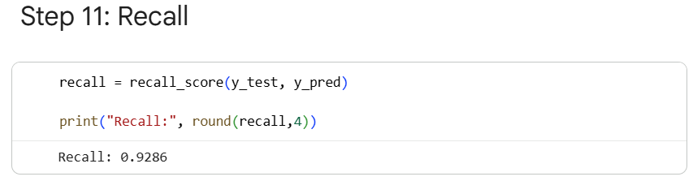
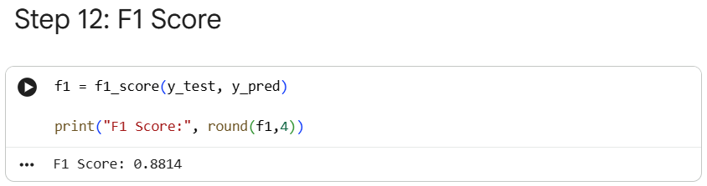
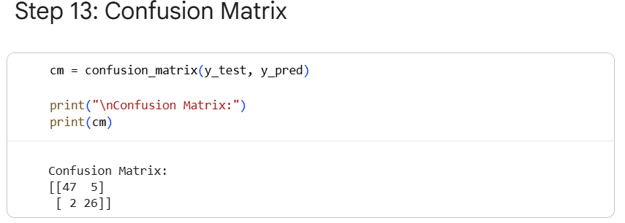
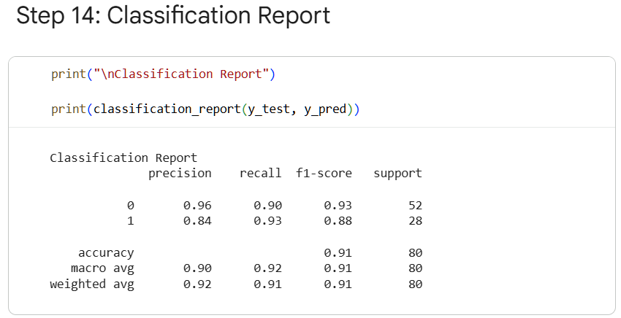
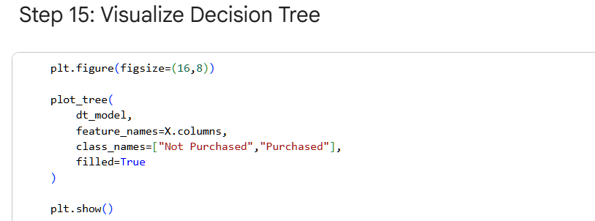
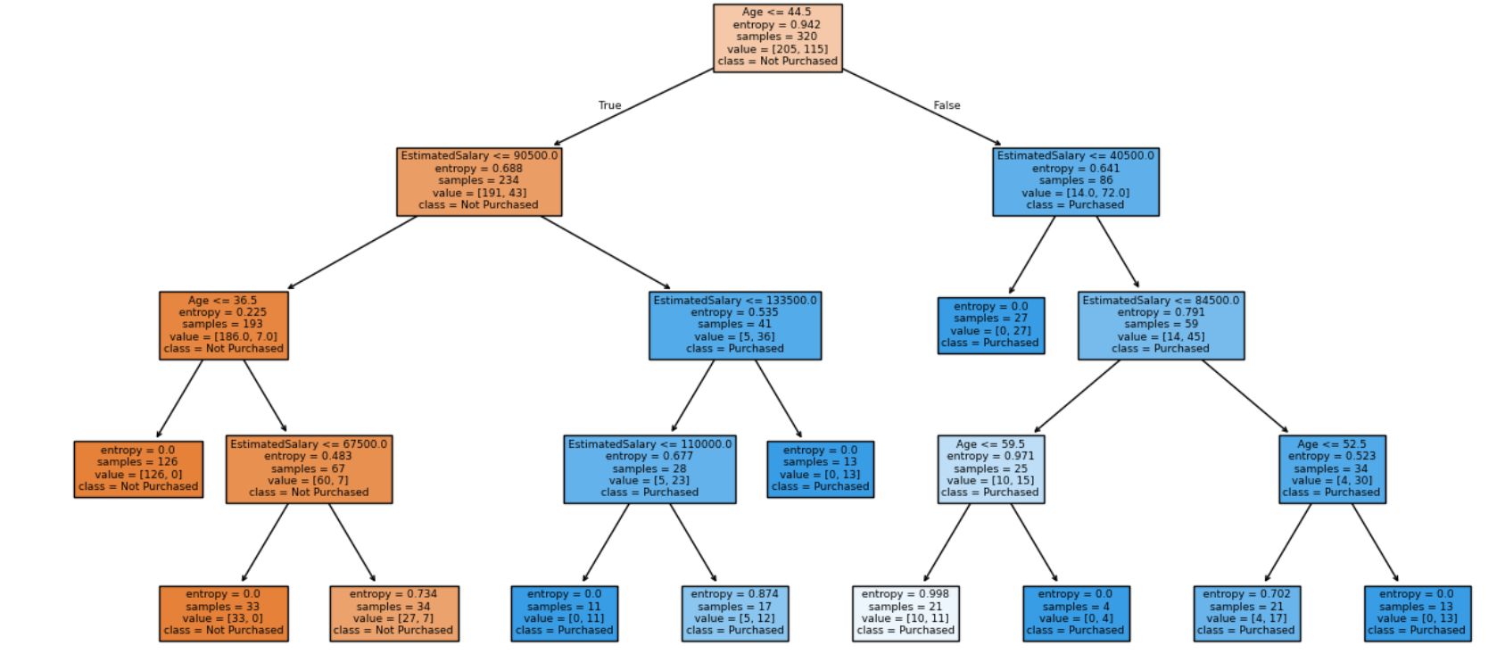
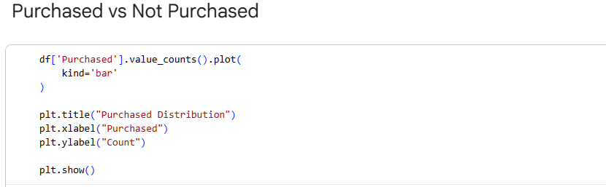
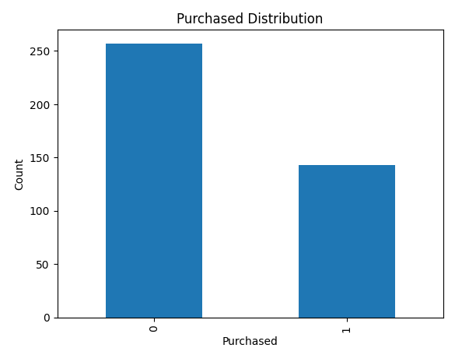
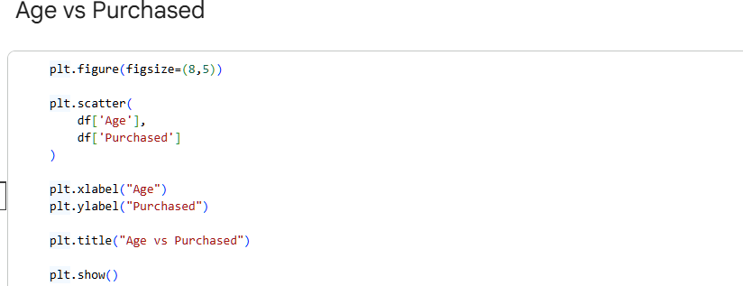
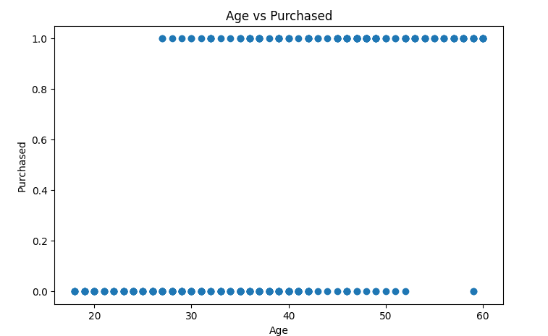
Lab Outcome
- Successfully loaded and explored the marketing dataset.
- Preprocessed categorical features using dummy encoding.
- Built and trained a Decision Tree classifier.
- Visualized the decision-making process of the model.
- Evaluated model performance using classification metrics.

LAB 10
Naïve Bayes & KNN
Real-World Problem
Scenario: An email service provider wants to automatically classify incoming emails as Spam or Not Spam.
Business Goal: Reduce unwanted emails and improve user experience.
Dataset Description
SMS Spam Collection Dataset.
Column | Description
Message | Text content of the SMS/email
Label | spam or ham (not spam)

Practical Objectives
- Convert text data into numerical features.
- Train and test a Naïve Bayes classifier.
- Train and test a K-Nearest Neighbors classifier.
- Compare the performance of both models.
Procedure
Step 1: Import Libraries
- TfidfVectorizer converts text into numeric vectors.
- MultinomialNB is suitable for text classification.
- KNeighborsClassifier implements the KNN algorithm.
Step 2: Load the Dataset
Verify that the dataset contains the message text and label columns.
Step 3: Prepare Features and Target
- X contains the raw text messages.
- y contains spam/ham labels.
- fit_transform() learns the vocabulary and converts text into TF-IDF features.
Step 4: Split the Dataset
The model is trained on 80% of the data and tested on 20%.
Step 5: Train Naïve Bayes Model
Naïve Bayes estimates probabilities of words appearing in spam and non-spam messages.
Step 6: Evaluate Naïve Bayes
The report shows precision, recall, and F1-score for both classes.
Step 7: Train KNN Model
KNN classifies a message based on the majority label among its 5 nearest neighbors.
Step 8: Evaluate KNN
Compare KNN results with Naïve Bayes to determine which performs better on the dataset.
Code Implementation
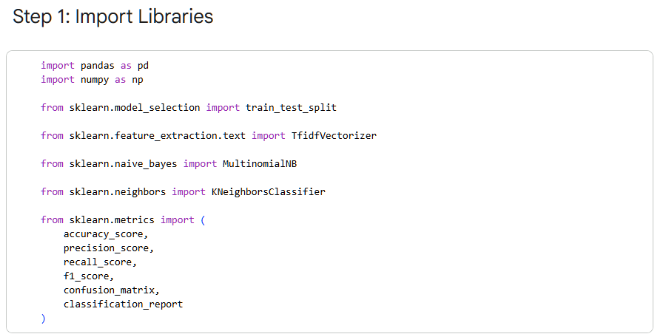
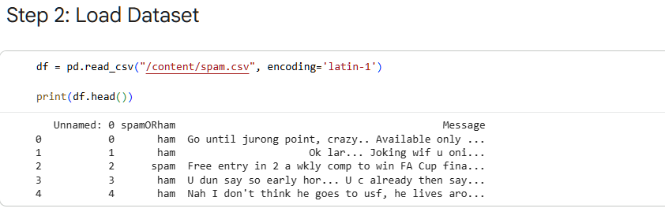
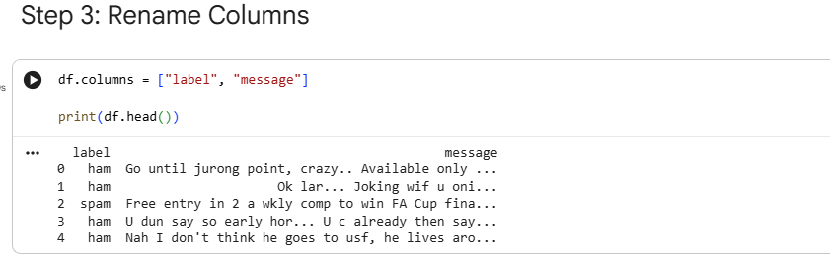
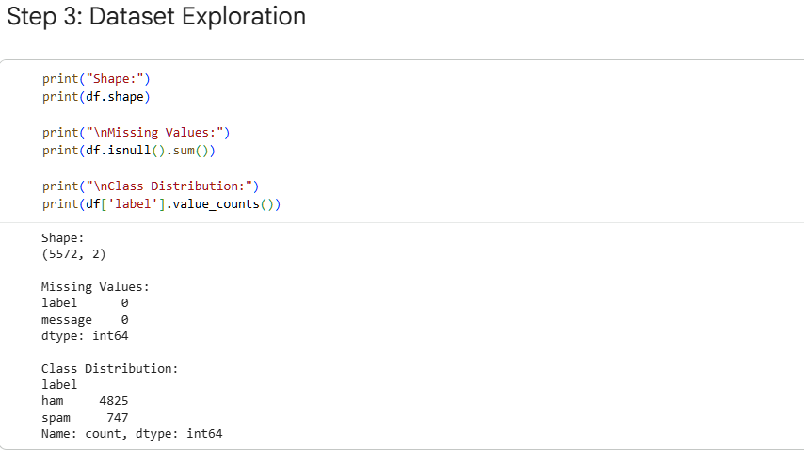
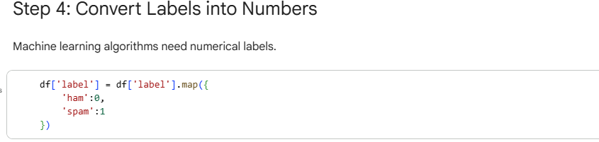
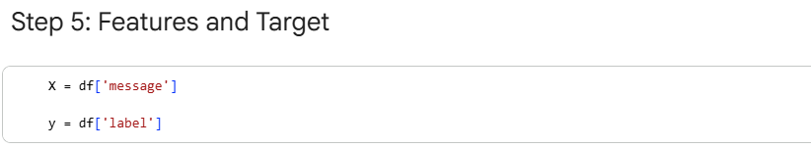
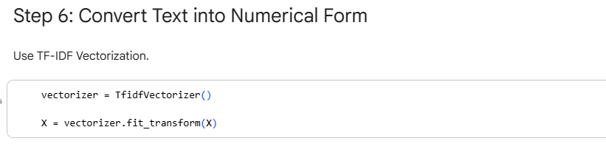
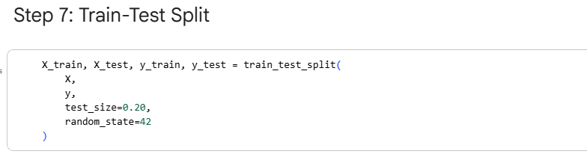
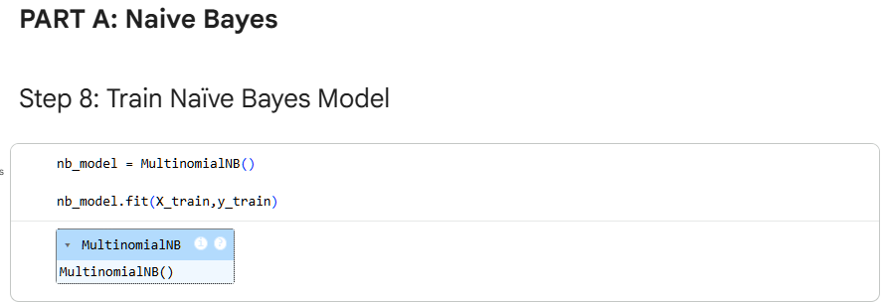
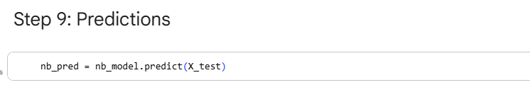
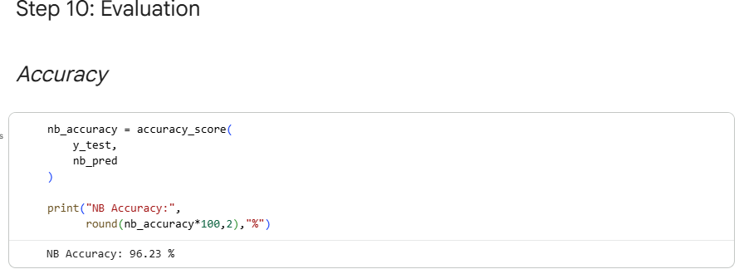
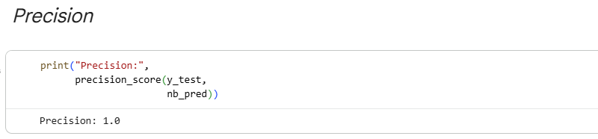
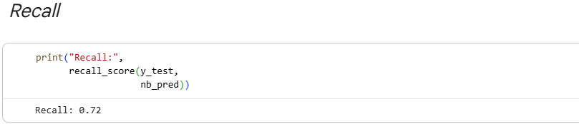
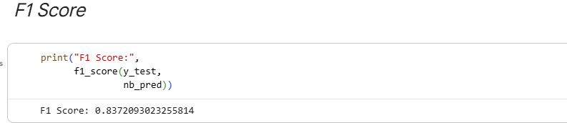
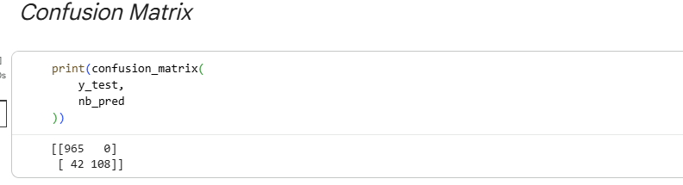
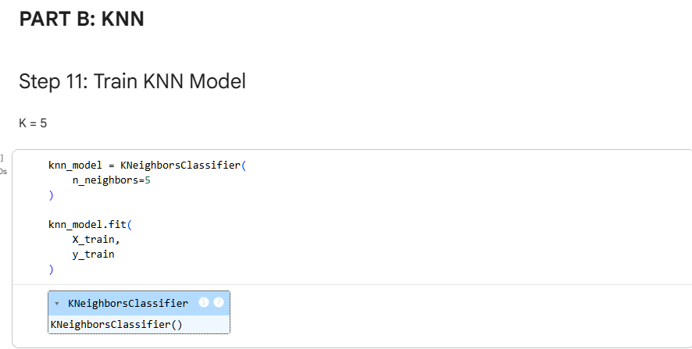
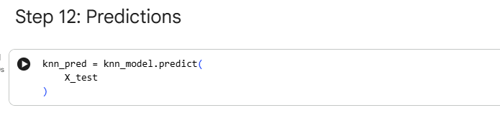
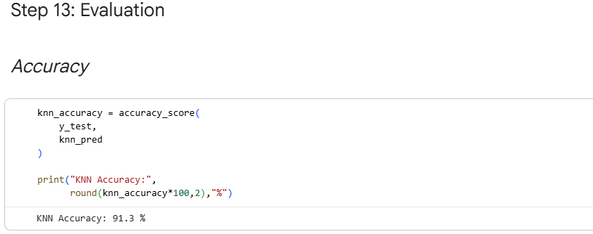
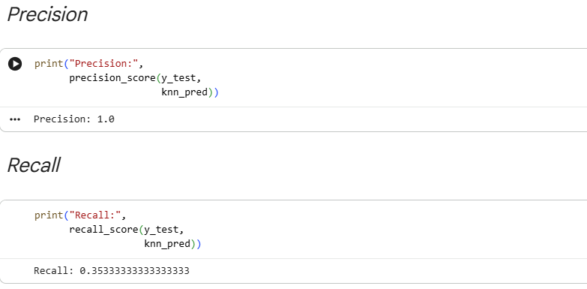
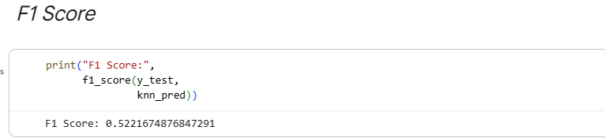
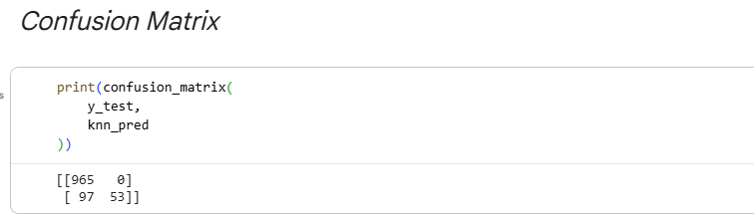
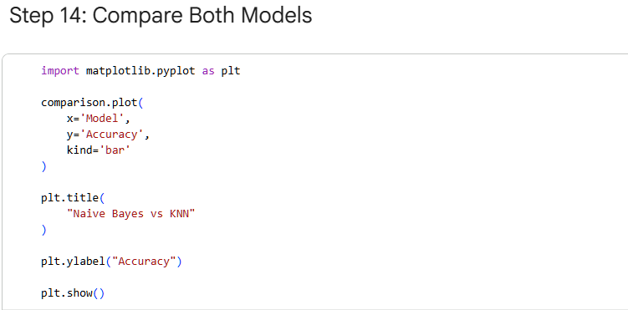
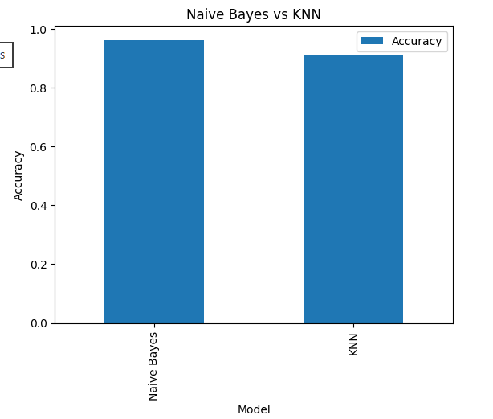
Lab Outcome
- Converted text messages into TF-IDF features.
- Built Naïve Bayes and KNN classifiers for spam detection.
- Compared model performance using accuracy and classification reports.
- Observed that Naïve Bayes is fast and effective for text classification, while KNN may perform differently depending on the dataset.

LAB 11
SVM (Support Vector Machine)
Real-World Problem
Scenario: A bank wants to detect fraudulent credit card transactions.
Business Goal: Minimize financial losses by identifying fraudulent transactions with high accuracy and recall.
Dataset Description
Credit Card Fraud Detection Dataset from Kaggle.
Column | Description
V1–V28 | Anonymized numerical features
Amount | Transaction amount
Time | Time elapsed since first transaction
Class | Target variable (0 = Normal, 1 = Fraud)
Practical Objectives
- Load and preprocess the fraud dataset.
- Train an SVM classifier with a linear kernel.
- Evaluate fraud detection performance using precision, recall, F1-score, and ROC-AUC.
- Understand the importance of recall in fraud detection.
Procedure
Step 1: Import Libraries
- SVC implements Support Vector Classification.
- roc_auc_score measures the model’s ability to distinguish fraud from non-fraud.
Step 2: Load the Dataset
Confirm that the dataset contains feature columns and the target column Class.
Step 3: Prepare Features and Target
- X contains transaction features.
- y contains fraud labels.
Step 4: Split the Dataset
stratify=y preserves the proportion of fraud and non-fraud cases in both sets.
Step 5: Train the SVM Model
- kernel='linear' creates a linear decision boundary.
- probability=True enables probability estimates for ROC-AUC calculation.
Step 6: Make Predictions
- predictions are the predicted classes.
- probabilities are the predicted fraud probabilities.
Step 7: Evaluate the Model
- Precision: How many predicted frauds were actually frauds.
- Recall: How many actual frauds were correctly detected.
- ROC-AUC: Overall separability between classes.
Code Implementation
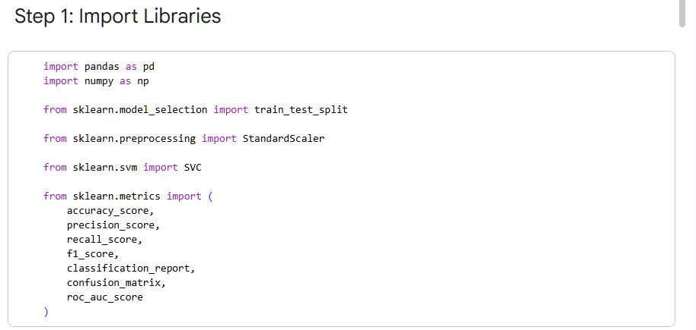
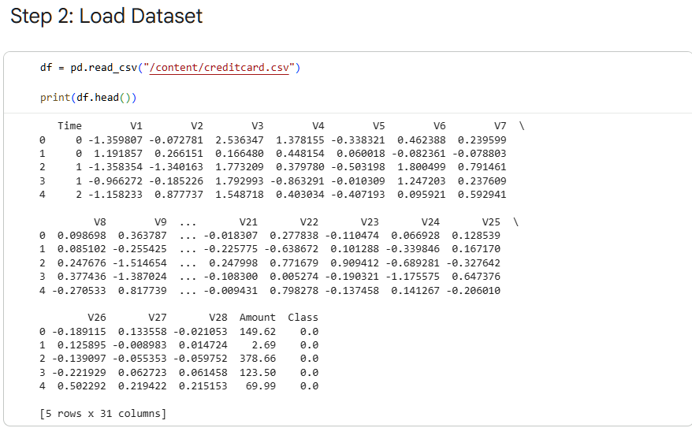
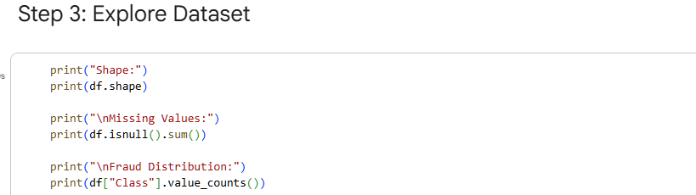
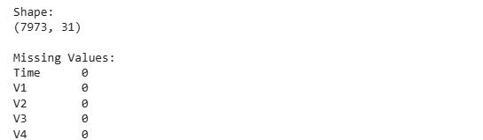
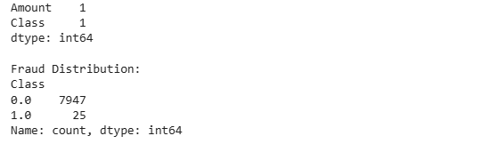
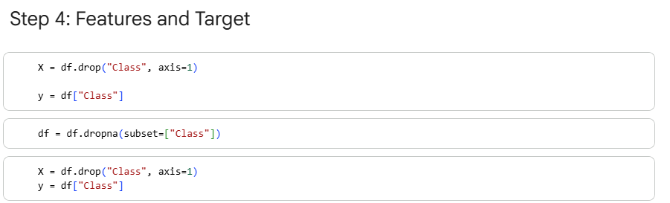
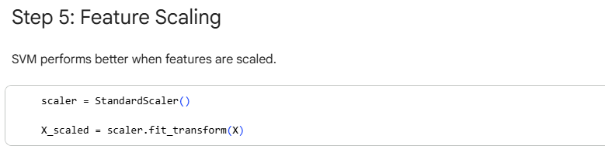
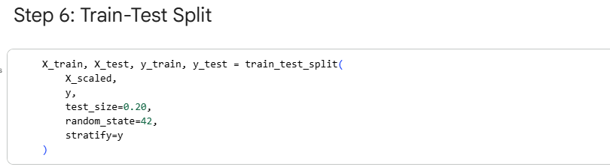
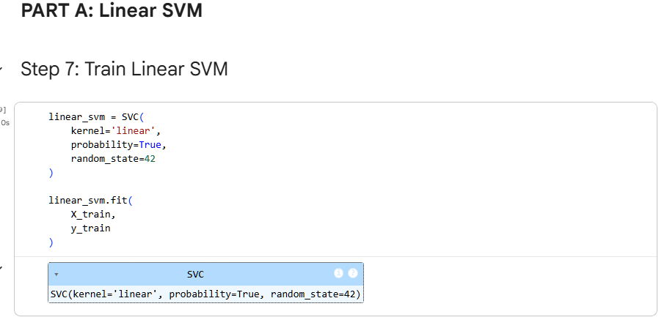
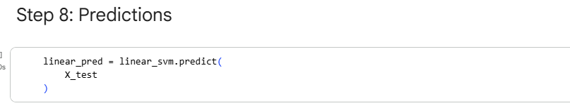
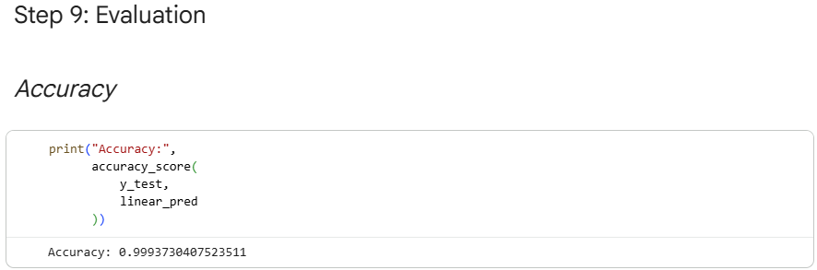
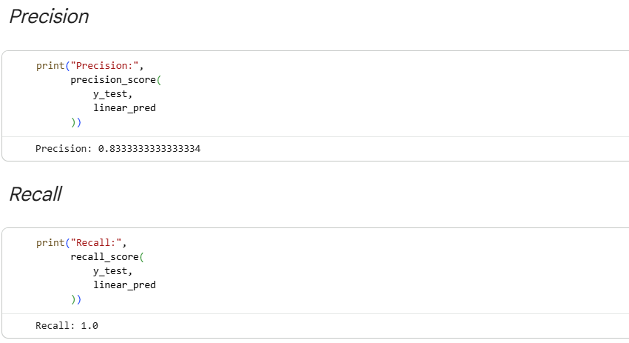

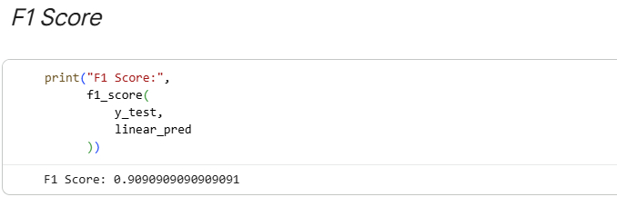
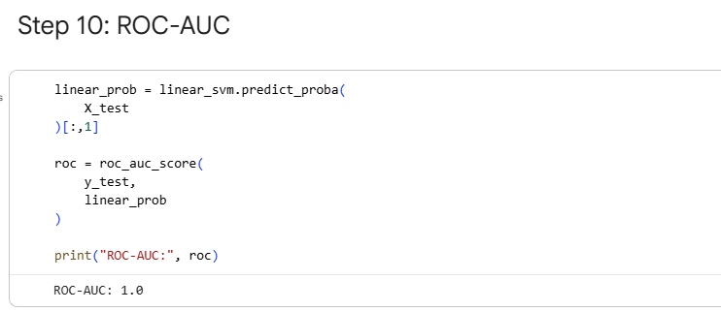
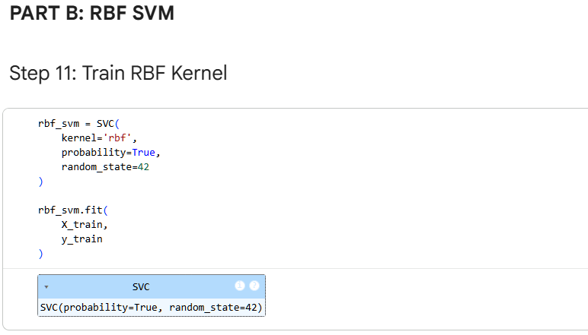
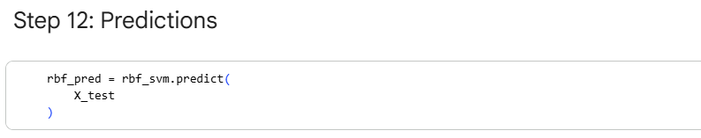
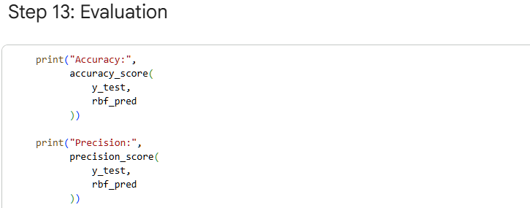
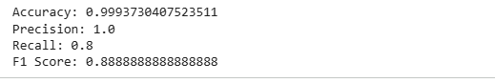
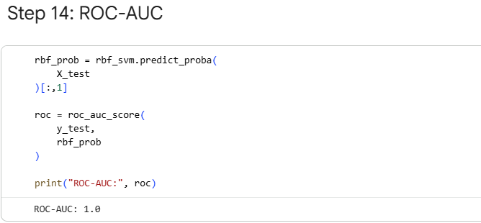
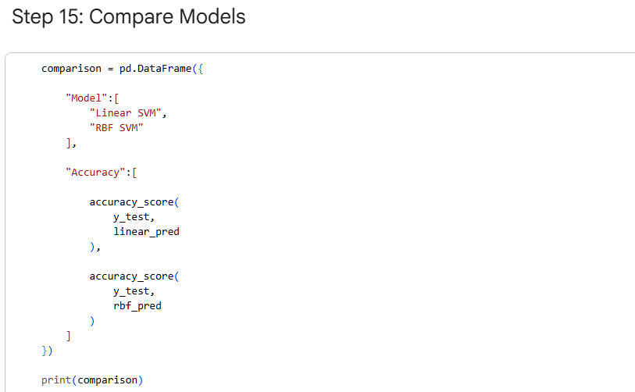
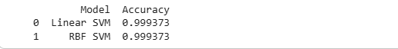
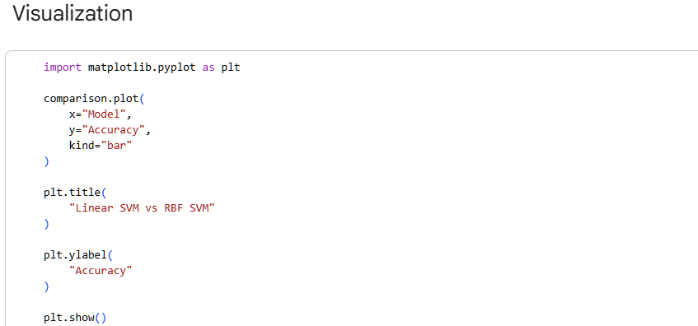
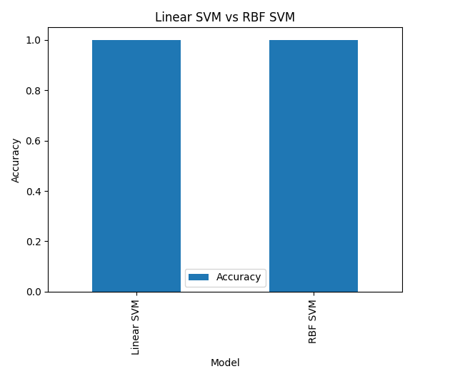
Lab Outcome
- Loaded and prepared the credit card fraud dataset.
- Trained a linear SVM classifier.
- Evaluated fraud detection performance using classification metrics and ROC-AUC.
- Understood why recall is critical in fraud detection to avoid missing fraudulent transactions.

LAB 12
CLUSTERING
Real-World Problem
Scenario: A shopping mall wants to segment customers into groups based on income and spending behavior.
Business Goal: Design targeted marketing campaigns for different customer segments.
Dataset Description
Mall Customer Segmentation Dataset.
Column | Description
CustomerID | Unique customer identifier
Gender | Male/Female
Age | Customer age
Annual Income (k$) | Annual income in thousand dollars
Spending Score (1-100) | Spending behavior score
Practical Objectives
- Visualize customer data.
- Apply K-Means clustering.
- Apply Hierarchical clustering.
- Compare clustering results and compute the Silhouette Score.
Procedure
Step 1: Import Libraries
- KMeans performs partition-based clustering.
- linkage and dendrogram are used for hierarchical clustering.
- silhouette_score evaluates cluster quality.
Step 2: Load the Dataset
Verify that income and spending score columns are available.

Step 3: Select Features
These two features are commonly used to identify customer segments.
Step 4: Visualize the Data
The scatter plot helps identify natural groupings in the data.
Step 5: Apply K-Means Clustering
- n_clusters=5 creates five customer groups.
- fit_predict() trains the model and assigns cluster labels.
Step 6: Visualize K-Means Clusters
Different colors represent different customer segments.
Step 7: Calculate Silhouette Score
A higher score indicates better-defined clusters.
Step 8: Apply Hierarchical Clustering
The dendrogram shows how customers are grouped at different distance thresholds.
Code Implementation
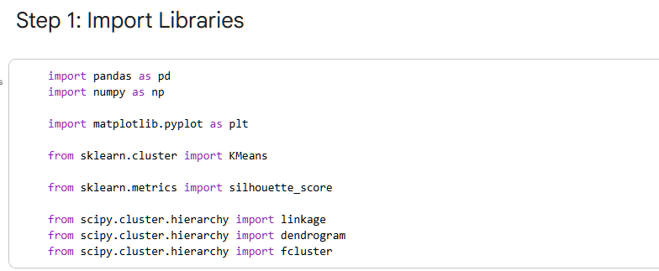
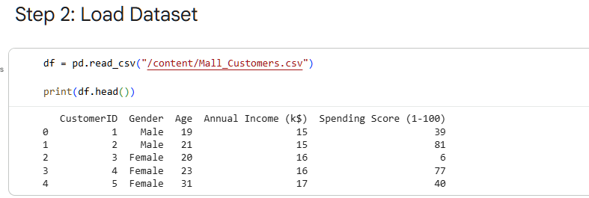
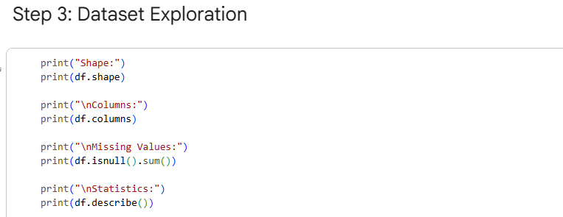
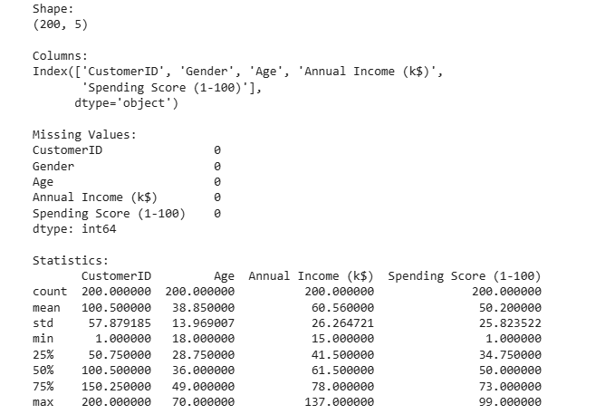
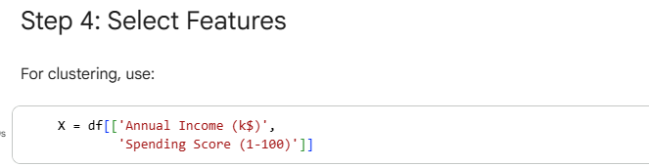
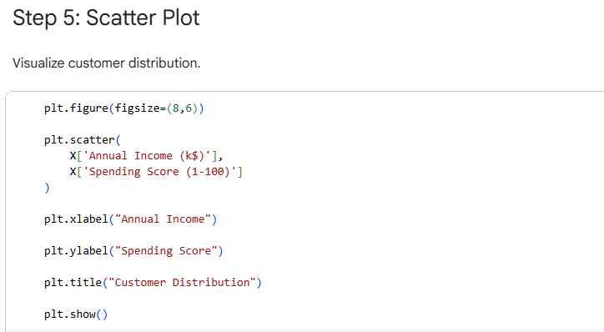
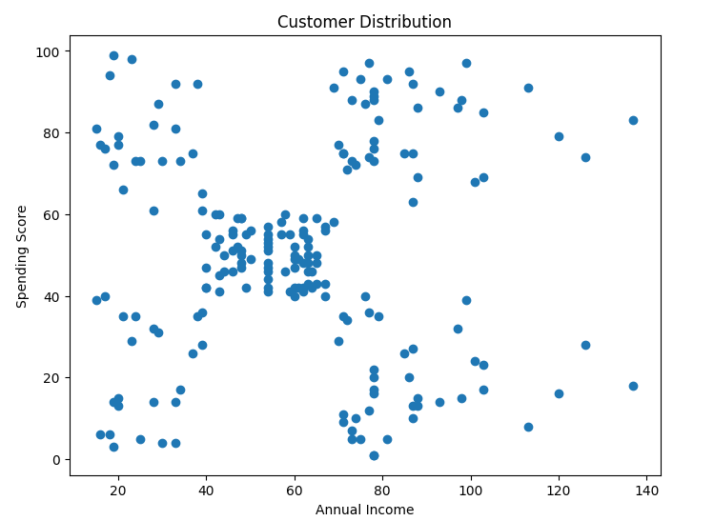
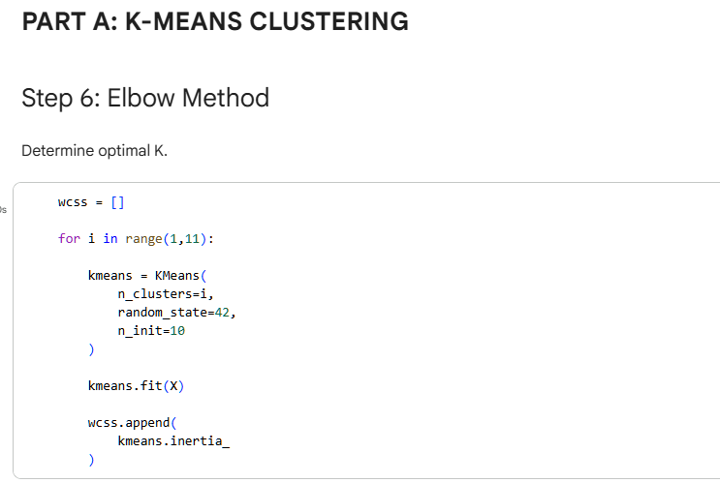
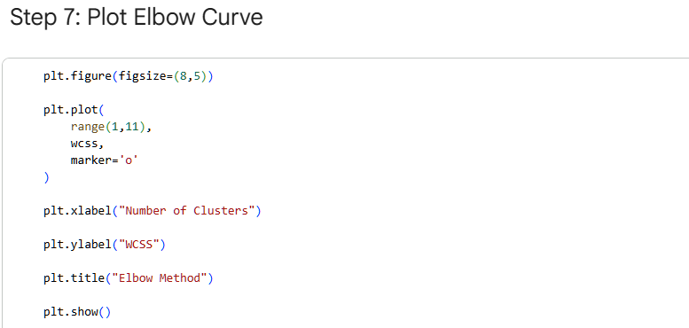
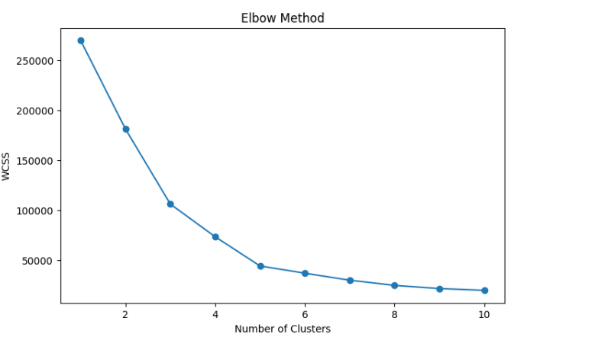
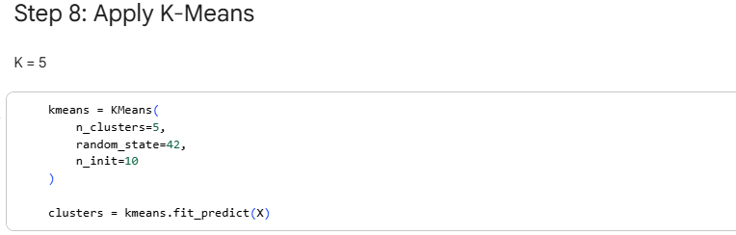
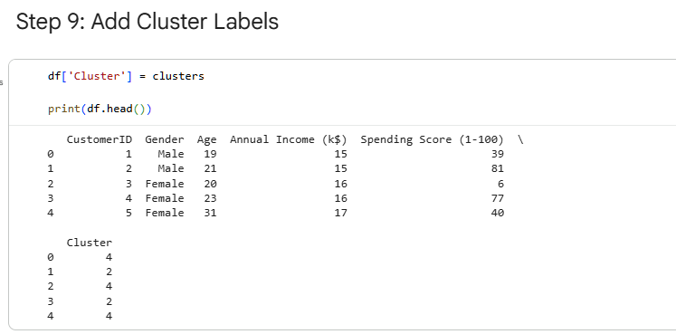
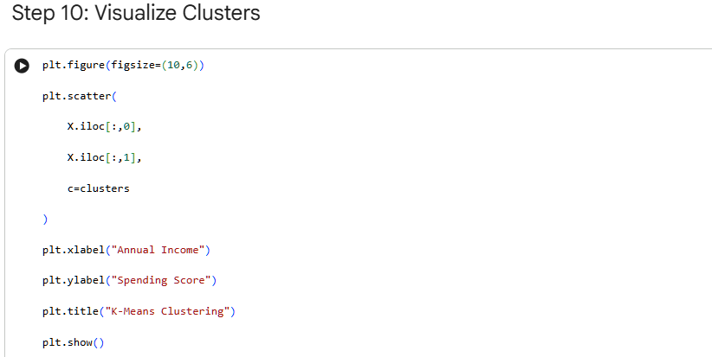
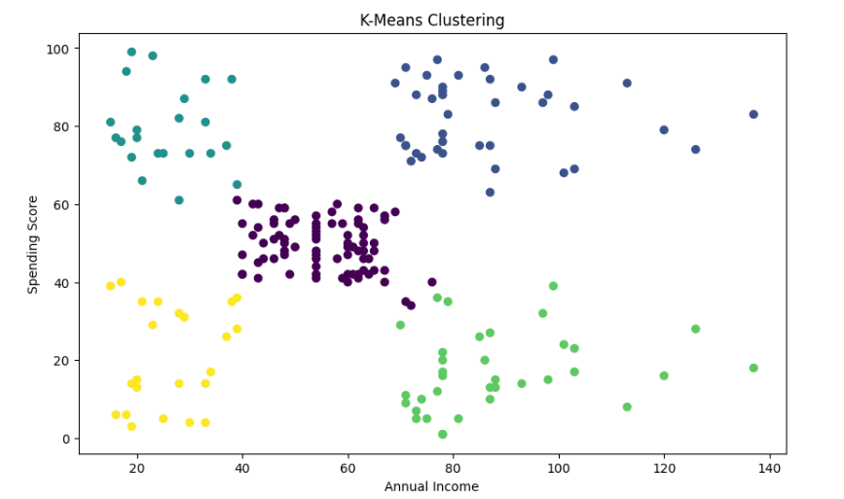
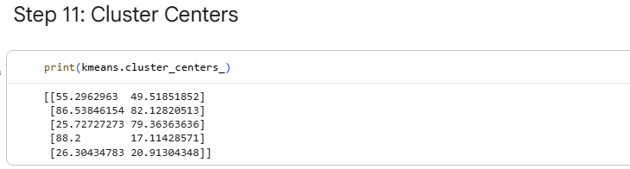
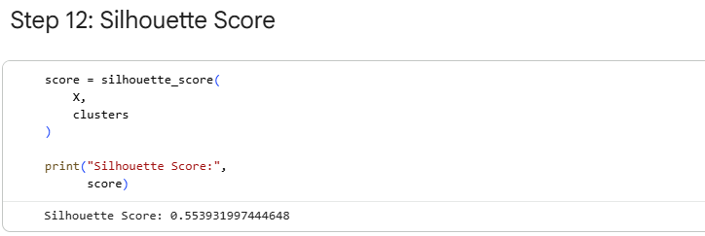
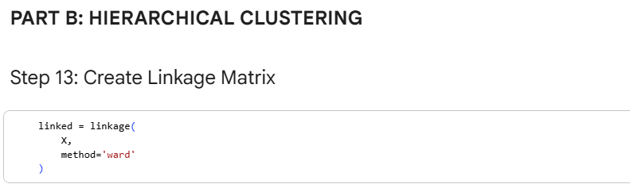
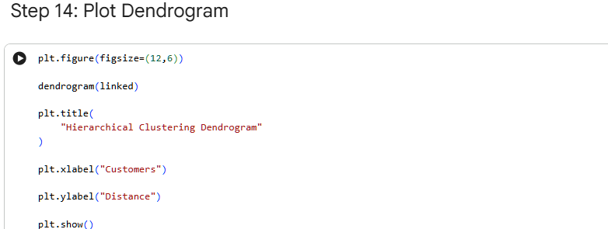
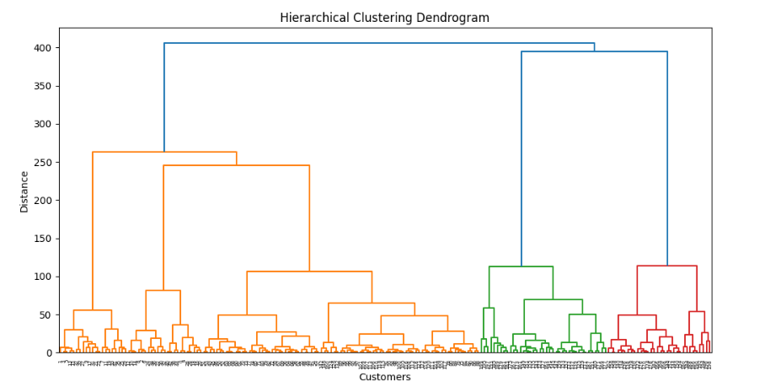
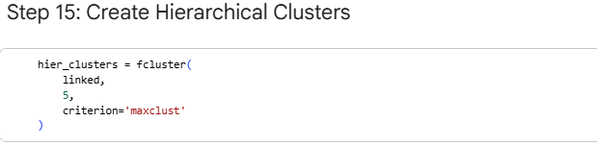
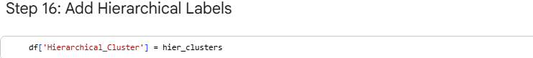
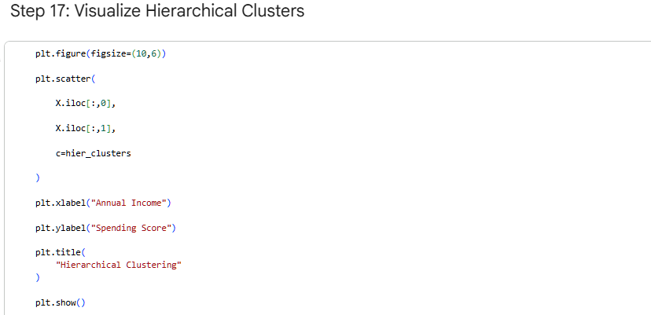
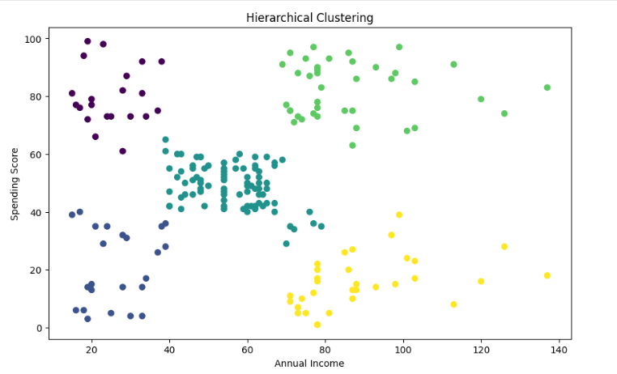
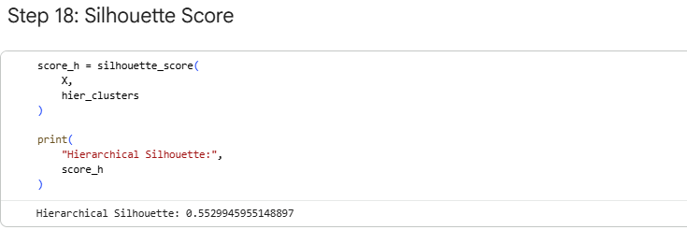
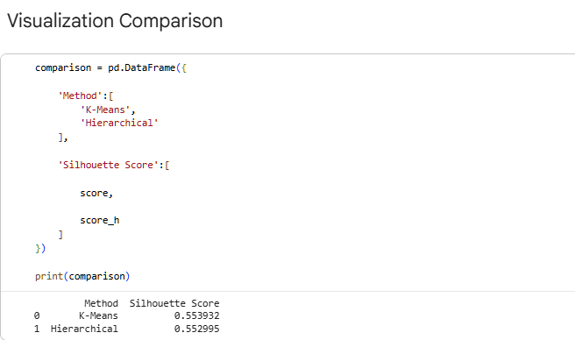
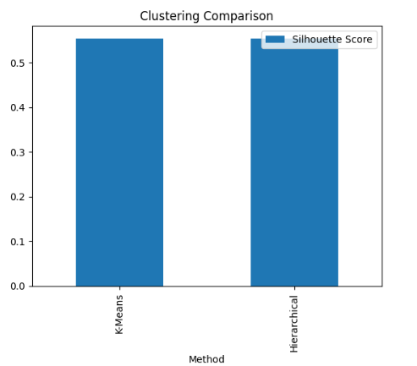
Lab Outcome
- Loaded and visualized customer segmentation data.
- Applied K-Means clustering to create customer groups.
- Evaluated cluster quality using the Silhouette Score.
- Used Hierarchical clustering and interpreted the dendrogram for customer grouping.

LAB 13
Outlier Detection
Real-World Problem
Scenario: A bank wants to detect abnormal transactions that may indicate fraud or unusual behavior.
Business Goal: Identify suspicious transactions early to reduce financial risk.
Dataset Description
Banking Transaction Dataset.
Column | Description
Transaction_ID | Unique transaction identifier
Amount | Transaction amount
Transaction_Type | Type of transaction
Location | Transaction location
Account_Age | Age of the account in months
Practical Objectives
- Detect outliers using a distance-based method.
- Detect outliers using Isolation Forest.
- Compare the detected anomalies.
Procedure
Step 1: Import Libraries
- LocalOutlierFactor (LOF) detects outliers based on local density.
- IsolationForest isolates anomalies using random partitioning.
Step 2: Load the Dataset
Confirm that the dataset contains numerical features suitable for anomaly detection.
Step 3: Select Numerical Features
Outlier detection algorithms work best with numerical data.
Step 4: Detect Outliers with LOF
- LOF compares the density of a point with its neighbors.
- Labels: -1 = outlier, 1 = normal.
Step 5: Detect Outliers with Isolation Forest
- contamination=0.02 assumes about 2% of transactions are anomalies.
- Isolation Forest isolates anomalies quickly because they are different from normal points.
Step 6: Compare Results
Compare how many transactions each method flags as anomalous.
Code Implementation
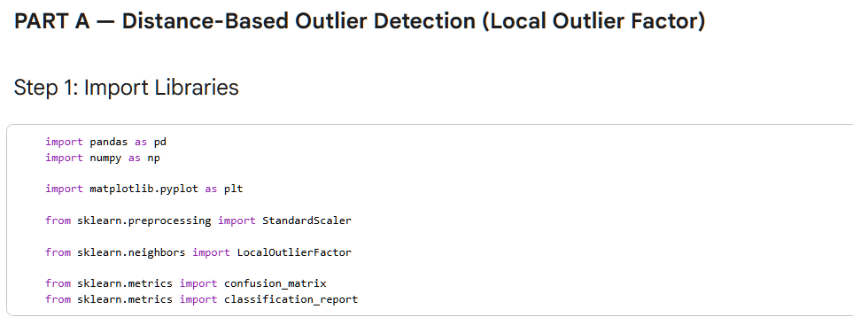
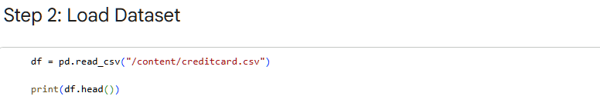
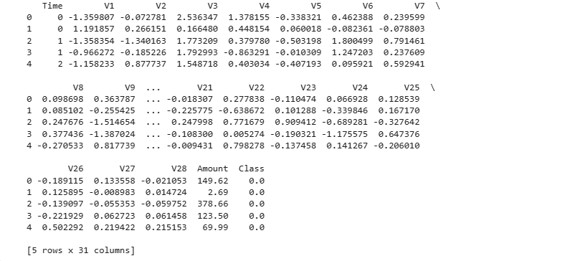
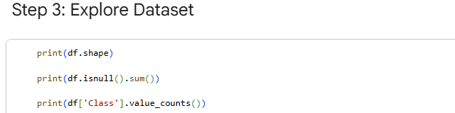
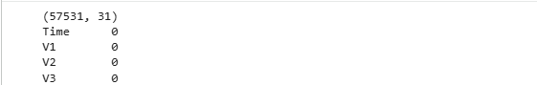
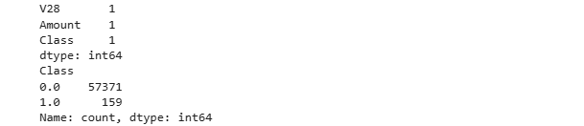
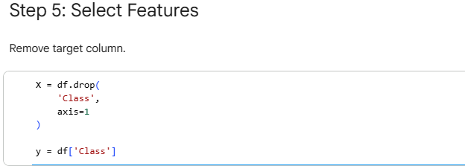
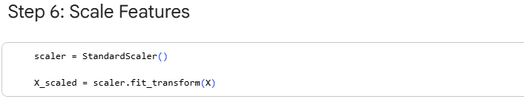
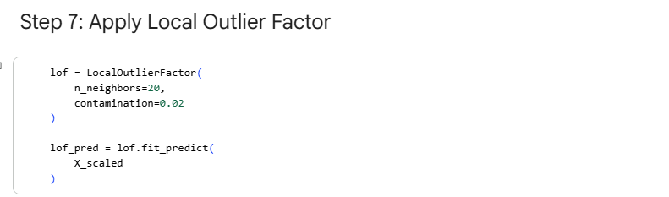
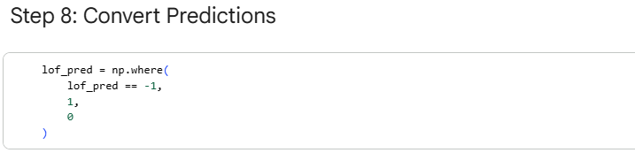
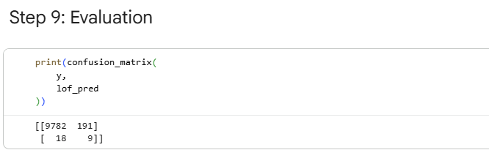
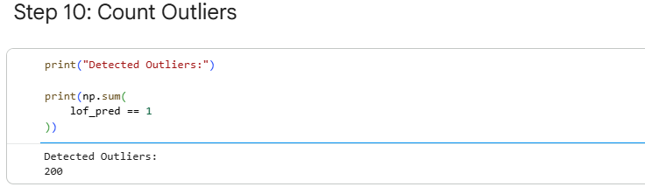
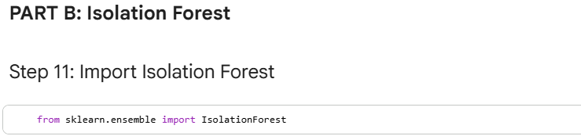
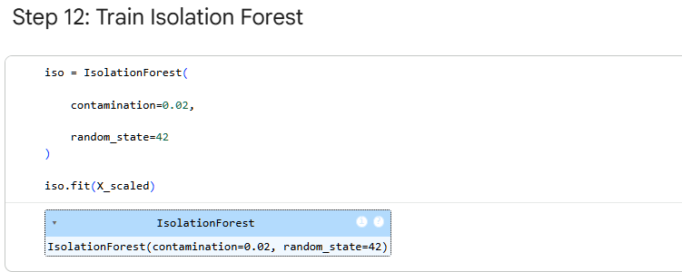
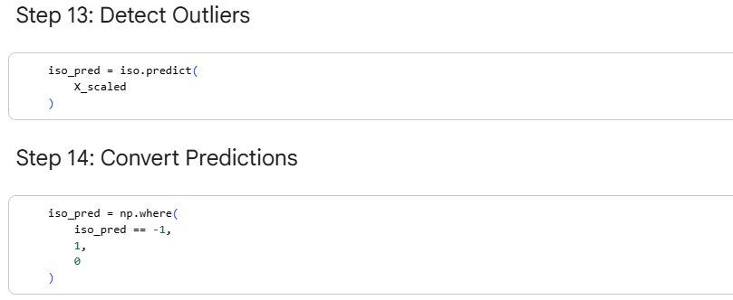
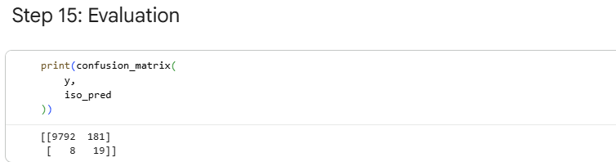
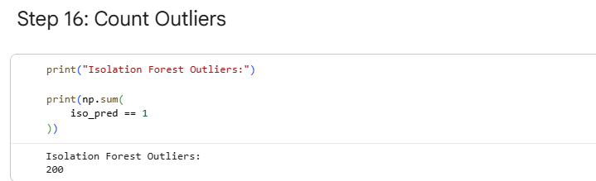
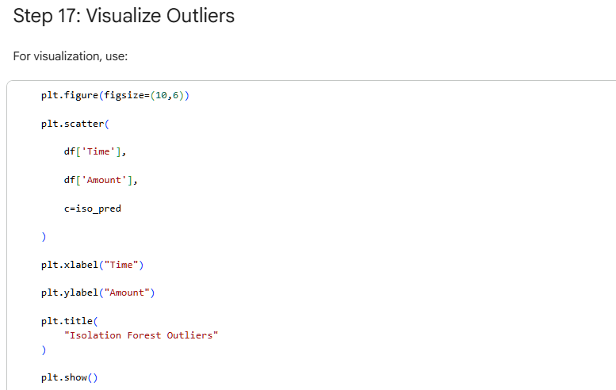
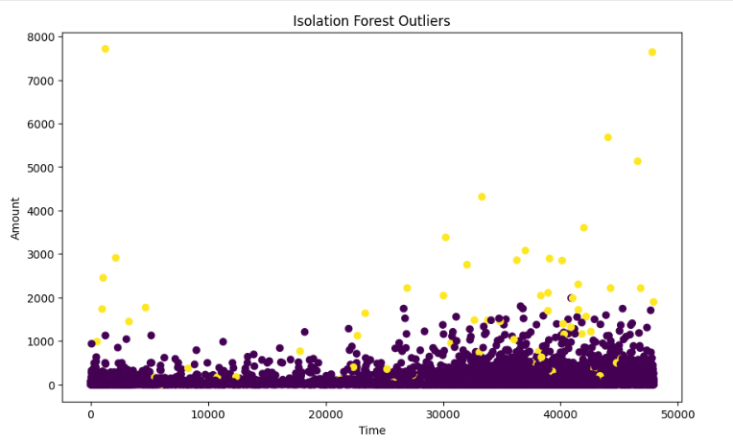
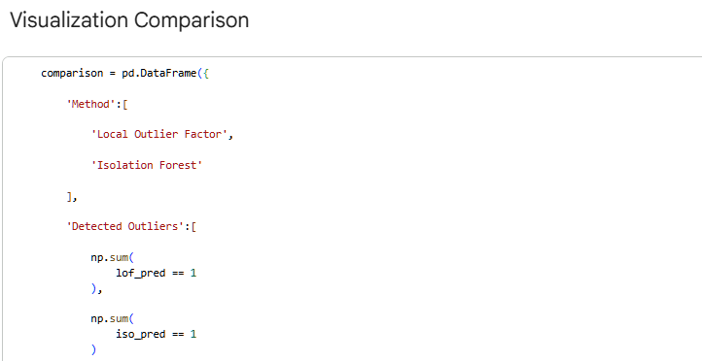
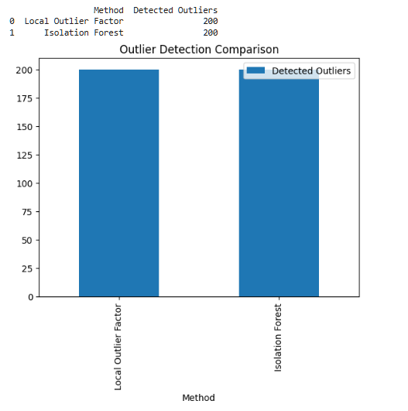
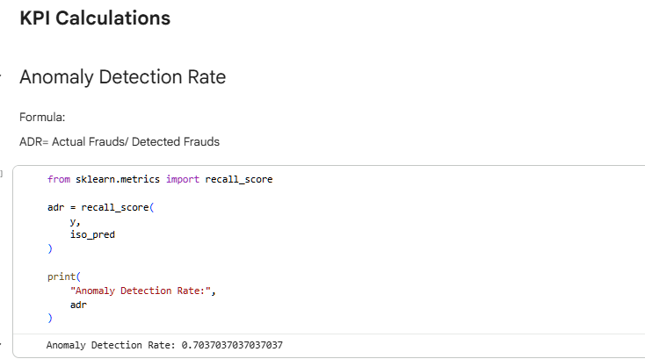
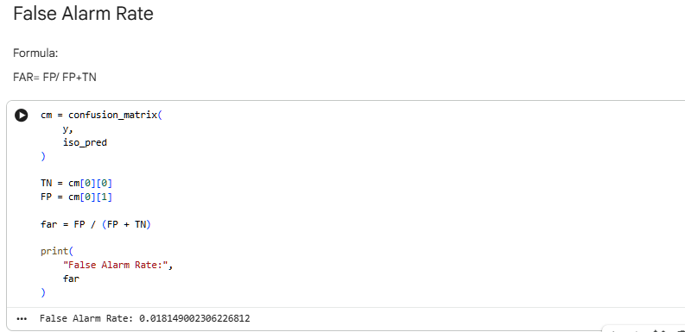
Lab Outcome
- Loaded and prepared banking transaction data.
- Detected anomalies using Local Outlier Factor and Isolation Forest.
- Compared the number and nature of detected outliers.
- Understood how outlier detection can help identify suspicious banking transactions.

LAB 14
Scraping & Sentiment Analysis
Real-World Problem
Scenario: A company wants to analyze customer reviews from websites or social media to understand public opinion about its products.
Business Goal: Measure customer satisfaction and identify common positive or negative feedback.
Dataset Description
- Scraped reviews from an e-commerce site
Typical Columns:
Column | Description
Review | Customer review text
Rating | Optional numerical rating
Date | Review date
Practical Objectives
- Scrape review data from a webpage.
- Clean and preprocess text data.
- Perform sentiment analysis to classify reviews as positive, negative, or neutral.
- Summarize sentiment distribution.
Procedure
Step 1: Import Libraries
- requests downloads webpage content.
- BeautifulSoup parses HTML.
- TextBlob performs sentiment analysis.
Step 2: Scrape Webpage Content
This downloads the webpage and extracts the page title as a simple scraping example.
Step 3: Create or Load Reviews Data
In a real project, this data would come from scraped reviews.
Step 4: Clean the Text
- Removes punctuation and numbers.
- Converts text to lowercase for consistency.
Step 5: Perform Sentiment Analysis
- TextBlob sentiment polarity: ranges from -1 (negative) to +1 (positive).
- Reviews are classified based on polarity.
Step 6: Summarize Sentiment Distribution
This shows how many reviews are positive, negative, and neutral.
Code Implementation
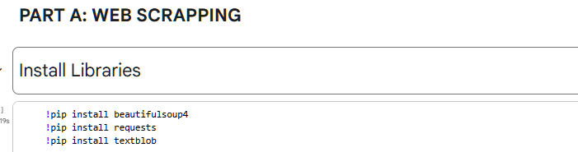
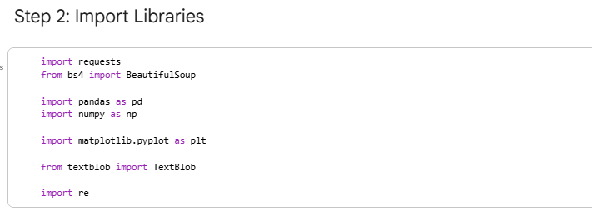
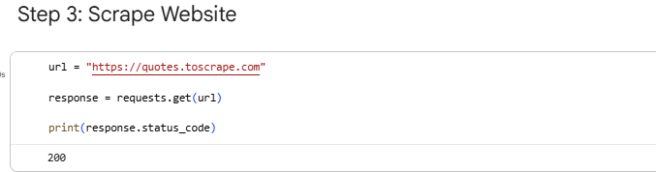
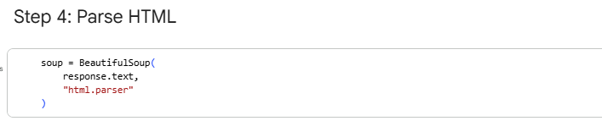
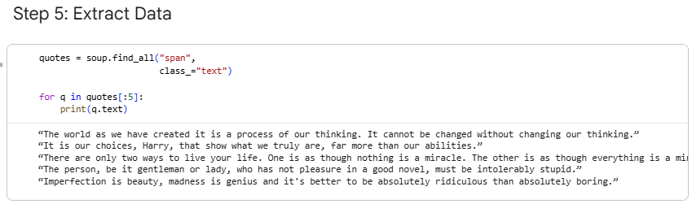
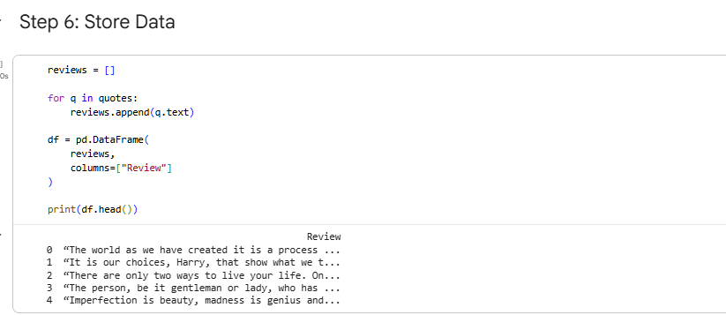
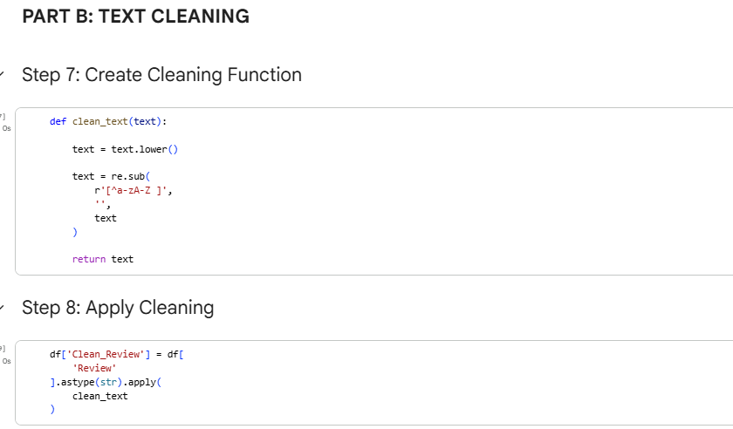
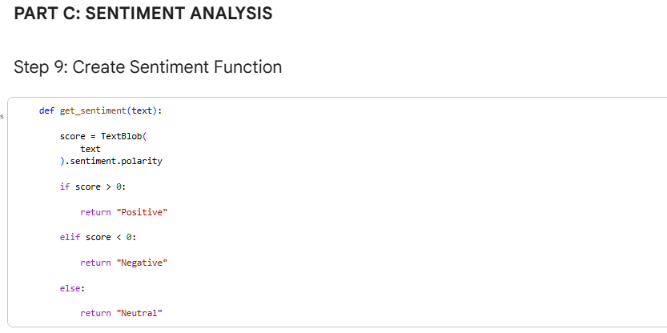
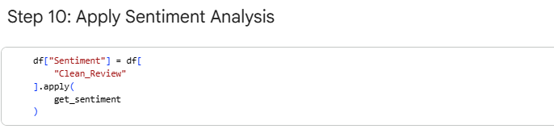
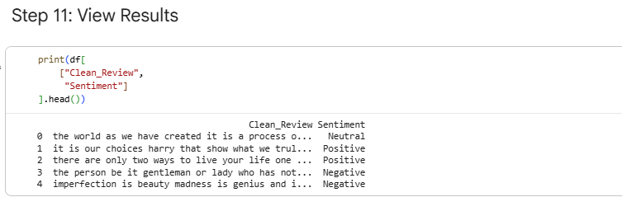
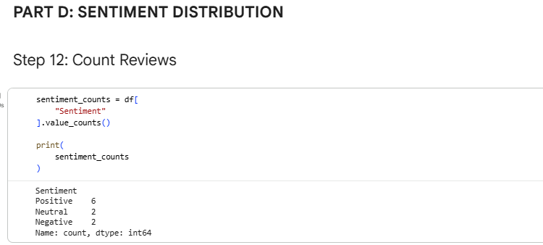
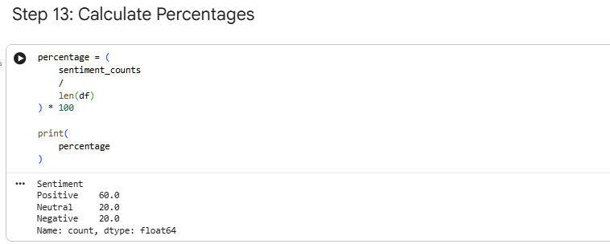
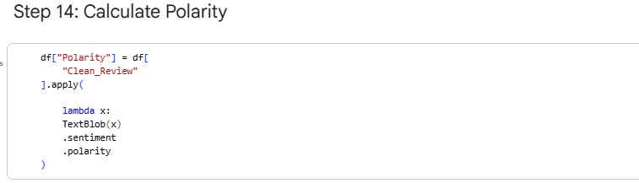
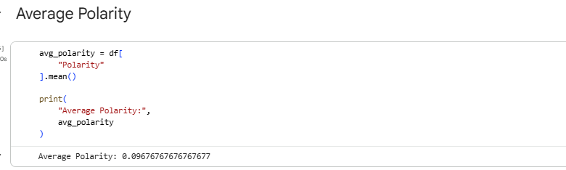
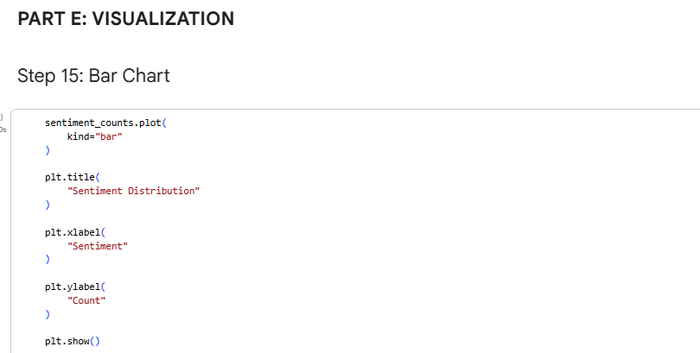
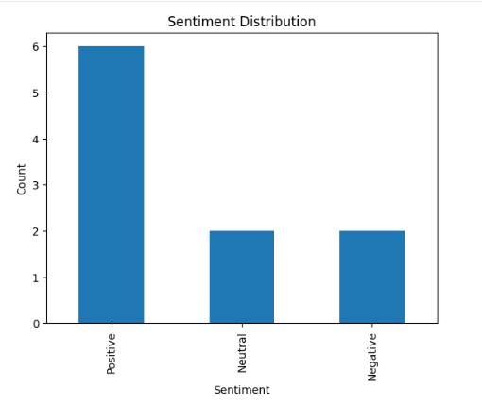
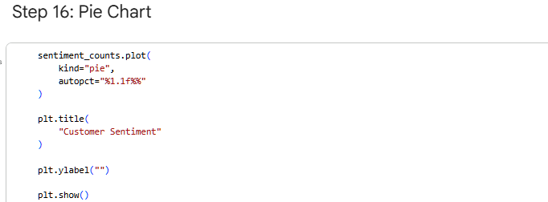
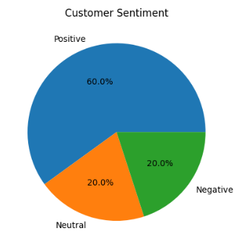
Lab Outcome
- Scraped and prepared review data for analysis.
- Cleaned textual data using regular expressions.
- Performed sentiment analysis with TextBlob.
- Summarized customer sentiment into positive, negative, and neutral categories

LAB 15
Final Capstone Project
Real-World Problem
Scenario: A business wants an end-to-end data mining solution to predict customer churn and improve retention.
Business Goal: Identify customers likely to leave and recommend strategies to retain them.
Dataset Description
Use a Customer Churn Dataset from Kaggle.
Column | Description
CustomerID | Unique customer identifier
Gender | Male/Female
Age | Customer age
Tenure | Months with the company
MonthlyCharges | Monthly bill amount
TotalCharges | Total amount charged
Churn | Target variable (Yes/No)

Practical Objectives
- Clean and preprocess the dataset.
- Perform exploratory data analysis (EDA).
- Train multiple machine learning models.
- Compare model performance.
- Provide business recommendations based on results.
Procedure
Step 1: Import Libraries
These libraries cover preprocessing, modeling, and evaluation for the capstone project.

Step 2: Load the Dataset
Verify the dataset structure and target column.
Step 3: Data Cleaning
- Removes duplicate records.
- Fills missing numerical values with the median.
Step 4: Encode Categorical Variables
Converts text categories into numeric values for machine learning models.
Step 5: Split Features and Target
Creates training and testing datasets for model evaluation.
Step 6: Scale Features
Standardization improves the performance of distance-based and SVM models.
Step 7: Train Multiple Models
Each model is trained and evaluated on the same test set for fair comparison.
Step 8: Compare Model Performance
The table ranks models by accuracy to identify the best-performing approach.
Step 9: Detailed Evaluation of Best Model
Suppose Random Forest performs best. The classification report provides precision, recall, and F1-score for the best model.
Step 10: Business Recommendations
Based on churn predictions, recommend actions such as:
- Offer discounts to high-risk customers.
- Improve customer support for long-tenure users.
- Monitor customers with rapidly increasing monthly charges.

Code Implementation:
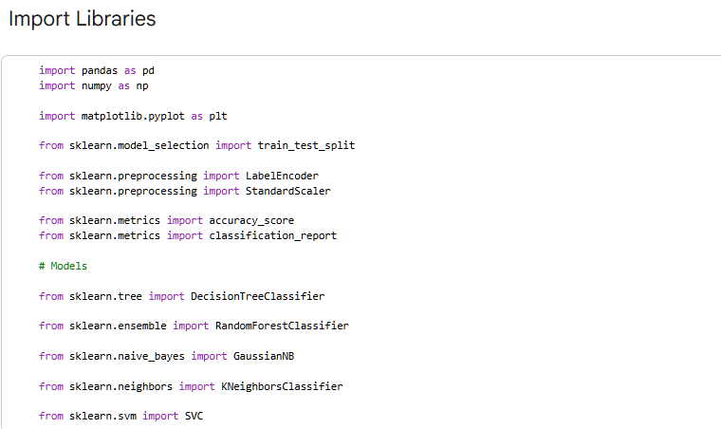
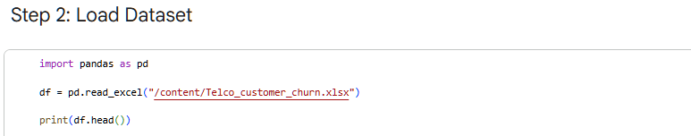
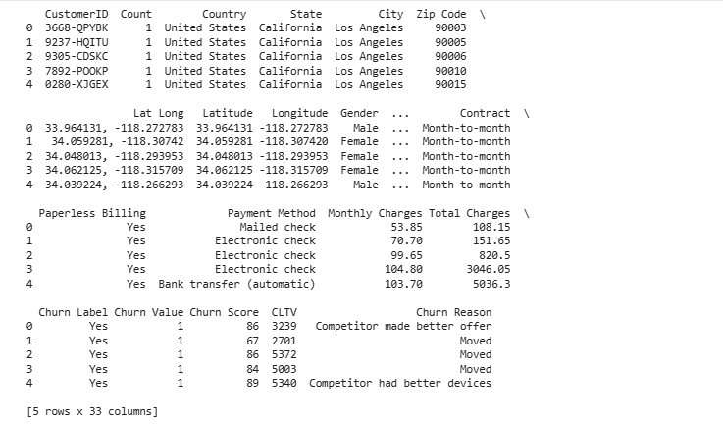
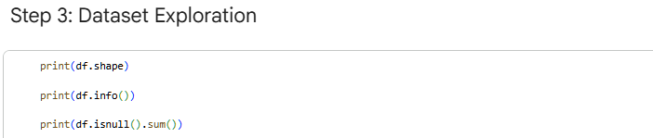
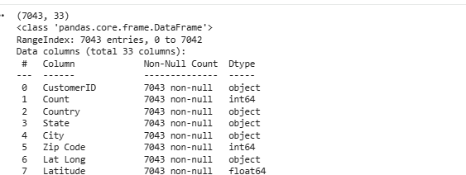
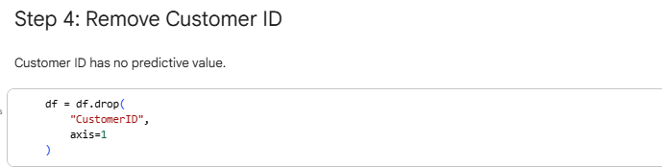
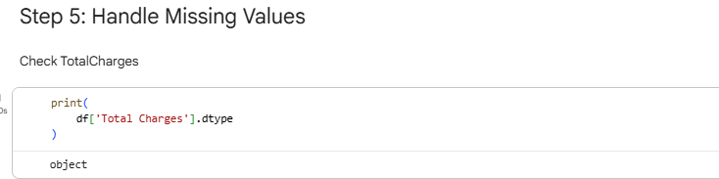
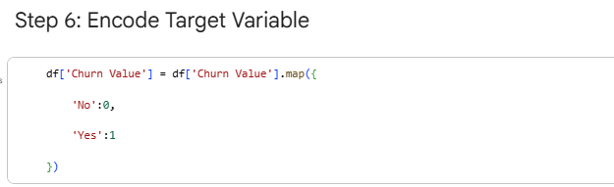
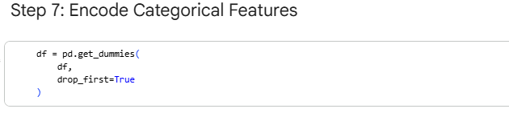
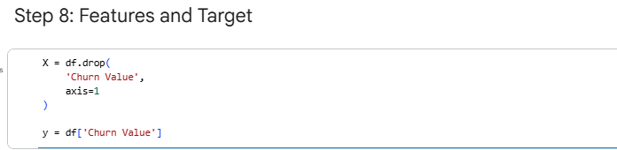
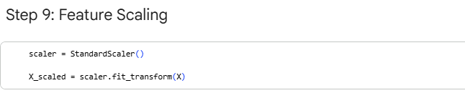
Lab Outcome
- Completed an end-to-end data mining pipeline.
- Cleaned, encoded, and standardized the dataset.
- Trained and compared multiple machine learning models.
- Identified the best-performing model for churn prediction.

